INTRODUCTION

1.1 INTRODUCTION

In our proposed system we are aiming to create an application using which the users can find the nearest charging stations of various companies with the help of GPS. Here a user can view the slots in a station, whether it is free or occupied using the mobile application without going there in person. He can book the slots from the app so that he only need to reach there on the time of his appointment.

The companies can manage a proper track of their transactions with the help of the application. A company register by its own and functions with the help of its consecutive staffs.

With the help of these applications, the companies can develop their business also. As plug-in hybrid electric vehicles and battery electric vehicle ownership is expanding, there is a growing need for widely distributed publicly accessible charging stations, some of which support faster charging at higher voltages and currents than are available from residential EVSEs.



METHODOLOGY

2.1 AGILE MODEL

Agile SDLC model is a combination of iterative and incremental process models with focus on process adaptability and customer satisfaction by rapid delivery of working software product. Agile Methods break the product into small incremental builds. These builds are provided in iterations. Each iteration typically lasts from about one to three weeks. Every iteration involves cross functional teams working simultaneously on various areas like –

* Planning
* Requirements Analysis
* Design
* Coding
* Unit Testing and
* Acceptance Testing

At the end of the iteration, a working product is displayed to the customer and important stakeholders.

What is Agile ?

Agile model believes that every project needs to be handled differently and the existing methods need to be tailored to best suit the project requirements. In Agile, the tasks are divided to time boxes (small time frames) to deliver specific features for a release.

Iterative approach is taken and working software build is delivered after each iteration. Each build is incremental in terms of features; the final build holds all the features required by the customer.

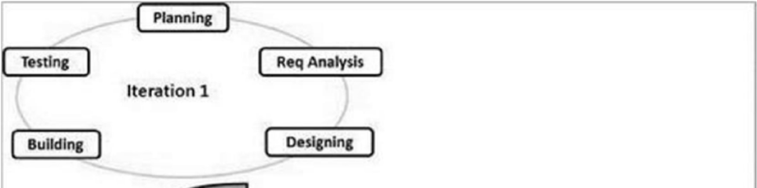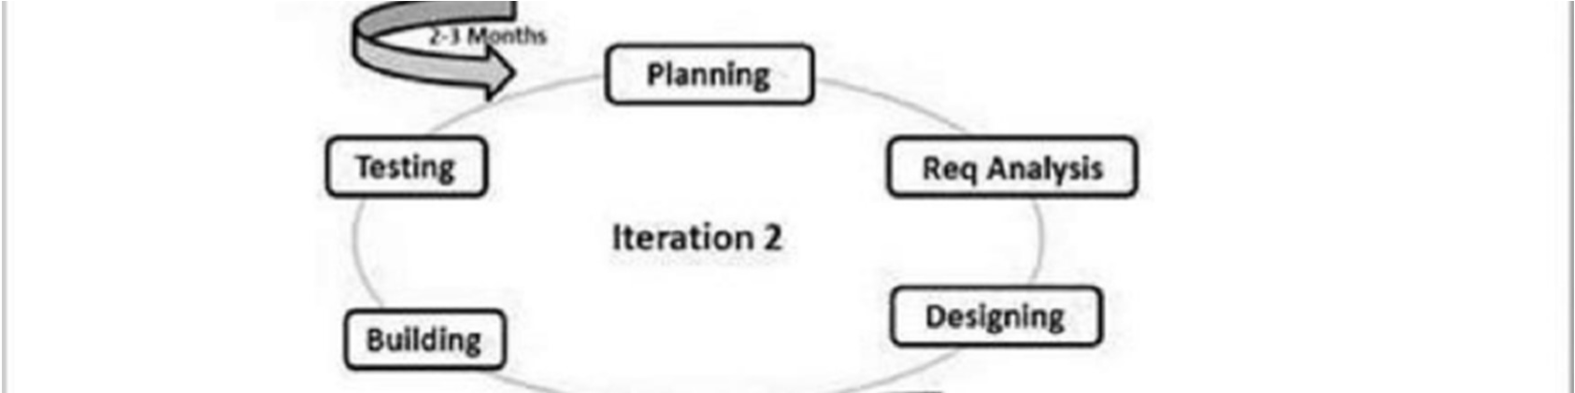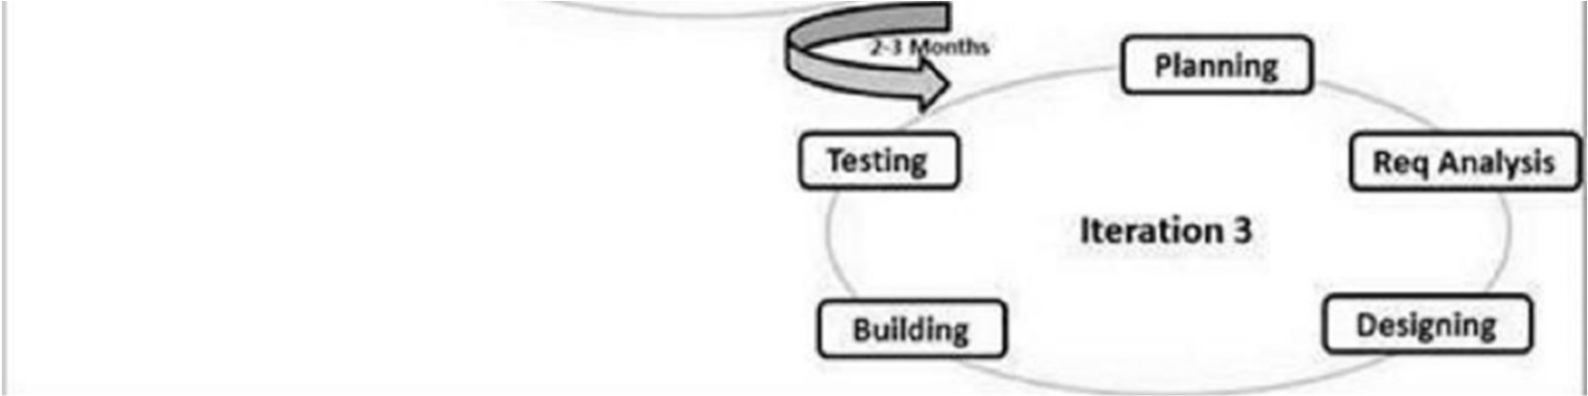



The Agile thought process had started early in the software development and started becoming popular with time due to its flexibility and adaptability.

The most popular agile methods include Rational Unified Process (1994), Scrum (1995), Crystal Clear, Extreme Programming (1996), Adaptive Software Development, Feature Driven Development, and Dynamic Systems Development Method (DSDM) (1995). These are now collectively referred to as Agile Methodologies, after the Agile Manifesto was published in 2001.

Following are the Agile Manifesto principles –

Individuals and interactions - In Agile development, self-organization and motivation are important, as are interactions like co-location and pair programming.

Working software - Demo working software is considered the best means of communication with the customers to understand their requirements, instead of just depending on documentation.

Customer collaboration - As the requirements cannot be gathered completely in the beginning of the project due to various factors, continuous customer interaction is very important to get proper product requirements.

Responding to change - Agile Development is focused on quick responses to change and continuous development.

SYSTEM ANALYSIS

3.1 SYSTEM ANALYSIS

System Analysis is concerned with analysing, designing, implementing and evaluating information system in our organization. It is carried out to make the system more effective either by modification or by substantial redesign. In system analysis we identify the problem, study the alternative solution and select the most suitable solution, which meet the technical economic and social demands for analysis, various tools such as dataflow diagram, interviews on site observation, questionnaires etc. are used. System analysis process is also called a life cycle methodology since it relates to four significant phases in life cycle of all information system.

They are

* System Analysis / Study Phase.
* System Design / Design Phase.
* System Development / Development Phase.
* Testing and Implementation / Operation Phase.

All activities associated with each life cycle phase must be performed managed and documented. So, system analysis is the performance, management and documentation of the activities related to the four life cycle phases of a computer-based system

EXISTING SYSTEM

The existing system is the manual system. In people should push the vehicle or get help to reach nearest electric recharge station. For some aged people or medically ill people it will get even hard. To get electric to fill generators people need to go to an electric recharge bunk station. So we introduced the new proposed system to overcome the difficulties and problems.

DRAWBACKS OF EXISTING SYSTEM

Lack of security

Lack of privacy

Risk in the management of the data

Less user friendly

Accuracy not guaranteed

PROPOSED SYSTEM

The purpose of the new system is to overcome the existing manual system by the help of computer software through the network connection that will make better and easy to accessing. The required software and hardware are easily available and easy to work with.

The main aim of the application is to find out the nearest recharge bunk from the users current locations. The new system access a charging station within its driving range and cruise around anywhere in the city upon being recharged The proposed system of EV charging mobile app to provide EV vehicle owner the convenience of locating charging stations, vacancy of charging slots getting status updates on charging. Help to easy way of charging of EV station and ensure smooth journeys long distance. Electric Vehicle Recharge Nearest Bunk Using Mobile Application.

FEASIBILITY STUDY

When a new project is proposed, it normally goes through feasibility assessment. Feasibility study is carried out to determine whether the proposed system is possible to develop with available resources and what should be the cost consideration. There are three areas of feasibility study.

Economic Feasibility

Technical Feasibility

Operational Feasibility

ECONOMIC FEASIBILITY

The proposed system must be evaluated from a technical viewpoint first, and then considering behavioural and economic feasibility. This feasibility study presents tangible and intangible benefits from the project by comparing the development cost and operational cost.

This evaluation looks at the financial aspects of the project. The cost to conduct a full system investigation, the cost of hardware and software, the benefits in the form of reduced expenditure are all discussed during the economic feasibility. The technique of cost benefit

analysis is often used a basis for assessing economic feasibility. It determines whether the investments needed to implement the system will be recovered.

The system "EVGO" is economically feasible, as the hardware and software resources required for the functioning of the system.

TECHNICAL FEASIBILITY

Technical feasibility is related to the software and equipment specified in the design for implementing a new system. It is the study of function, performance and constraints that may affect the ability to achieve an acceptable system. Technical feasibility includes whether the technology is available on the market for development and its availability. During technical analysis, the analyst evaluates the technical merits of the system, at the same time collecting

SYSTEM SPECIFICATION

4.1 SYSTEM REQUIREMENTS

System requirements are the configuration that a system must have in order for a hardware or software application to run smoothly and efficiently. Failure to meet these requirements can result in installation problems or performance problems. The former may prevent a device or application from getting installed, whereas the latter may cause a product to malfunction or perform below expectation or even to hang or crash.

There are two types of requirements:

4.1.1 HARDWARE REQUIRMENTS

It is recommended that for optimal performance, the following minimum hardware is installed on the server on which the portal is hosted as well as on clients that access the portal. Give a minimum configuration like RAM, Hard disk, mouse, keyboard, processor, etc.

* + - * INPUT DEVICES : KEYBOARD, MOUSE
      * OUTPUT DEVICES : MONITOR
      * MEMORY : 8 GB RAM ( MINIMUM )
      * PROCESSOR : INTEL i3 PROCESSOR

4.1.2 SOFTWARE REQUIRMENTS

Software system requirements, in addition to the above mentioned requirements, may also specify additional software dependencies (e.g., libraries, driver version, framework version).For the proposed system to work properly, it is necessary that following software are installed and running on the server/client.

* + - * OPERATING SYSTEM : WINDOWS 7
      * FRONT END : DJANGO, ANDROID
      * BACK END : MySQL
      * SOFTWARE USED : PYCHARM IDE
      * LANGUAGE USED : PYTHON DJANGO FRAME WORK
      * WEB BROWSER : GOOGLE CHROME

SOFTWARE DESCRIPTION

5.1 FRONT END DESCRIPTION

5.1.1 PYTHON DJANGO

Python is a high-level, interpreted, interactive and object-oriented scripting language. Python is designed to be highly readable. It uses English keywords frequently where as other languages use punctuation, and it has fewer syntactical constructions than other languages.

* Python is Interpreted − Python is processed at runtime by the interpreter. You do not need to compile your program before executing it. This is similar to PERL and PHP.
* Python is Interactive − You can actually sit at a Python prompt and interact with the interpreter directly to write your programs.
* Python is Object-Oriented − Python supports Object-Oriented style or technique of programming that encapsulates code within objects.
* Python is a Beginner's Language − Python is a great language for the beginner-level programmers and supports the development of a wide range of applications from simple text processing to WWW browsers to games.

History of Python

Python was developed by Guido van Rossum in the late eighties and early nineties at the National Research Institute for Mathematics and Computer Science in the Netherlands.

Python is derived from many other languages, including ABC, Modula-3, C, C++, Algol-68, SmallTalk, and Unix shell and other scripting languages.

Python is copyrighted. Like Perl, Python source code is now available under the GNU General Public License (GPL).

Python is now maintained by a core development team at the institute, although Guido van Rossum still holds a vital role in directing its progress.

Python Features

Python's features include −

* Easy-to-learn − Python has few keywords, simple structure, and a clearly defined syntax. This allows the student to pick up the language quickly.
* Easy-to-read − Python code is more clearly defined and visible to the eyes.
* Easy-to-maintain − Python's source code is fairly easy-to-maintain.
* A broad standard library − Python's bulk of the library is very portable and cross-platform compatible on UNIX, Windows, and Macintosh.
* Interactive Mode − Python has support for an interactive mode which allows interactive testing and debugging of snippets of code.
* Portable − Python can run on a wide variety of hardware platforms and has the same interface on all platforms.
* Extendable − You can add low-level modules to the Python interpreter. These modules enable programmers to add to or customize their tools to be more efficient.
* Databases − Python provides interfaces to all major commercial databases.
* GUI Programming − Python supports GUI applications that can be created and ported to many system calls, libraries and windows systems, such as Windows MFC, Macintosh, and the X Window system of Unix.
* Scalable − Python provides a better structure and support for large programs than shell scripting.

Python Flask

Python Flask is a web framework for Python that is designed to make it easy to build web applications quickly and easily. Flask is based on the WSGI toolkit and Jinja2 templating engine, and provides a simple and intuitive interface for developers.

One of the key advantages of using Flask is its flexibility. Flask can be used for a wide range of web applications, from small personal projects to large-scale enterprise applications. It is also designed to be easy to use, which means that even developers with limited experience can quickly get up and running with Flask.

Flask provides a range of built-in features that make it easy to build web applications quickly and easily. These features include support for HTTP requests and responses, form handling, and authentication and authorization. Flask also provides a range of extensions that can be used to add additional functionality to your application, such as database support, caching, and testing tools.

One of the key features of Flask is its lightweight and minimalist design. Flask is designed to be simple and easy to use, with a focus on providing a small core set of features that can be easily extended as needed. This makes it an ideal choice for developers who want to build web applications quickly and easily, without having to spend a lot of time on configuration and setup.

Admin interface - allows developers to easily manage database records and user accounts.

5.1.2 ANDROID

Android Studio is the official integrated development environment (IDE) for Google's Android operating system, built on Jet Brains' Intelligent IDEA software and designed specifically for Android development. It is available for download on Windows, macOS and Linux based operating systems. It is a replacement for the Eclipse Android Development Tools (ADT) as the primary IDE for native Android application development.

Android Studio was announced on May 16, 2013 at the Google I/O conference. It was in early access preview stage starting from version 0.1 in May 2013, then entered beta stage starting from version 0.8 which was released in June 2014. The first stable build was released in December 2014, starting from version 1.0. The current stable version is 3.2.1, which was released in October 2018.

Android Fundamentals and Components

Important building blocks / components of android are as below.

* Activities
* Services
* Broadcast Receivers
* Content Providers

When we are developing application, always we will have some requirements like, passing messages with in an application (one screen to another) or between different applications. For example: Let’s say a new message came to your phone, so we update the notification bar for that new message. So, we will have to pass the information from message application to notification bar. Moral of the story is, the means of communication between the above-mentioned components is through the below components.

Intents Intent Filters Let’s come to the GUI part. The User Interface elements are made up the below components, which we called:

Android Activity

Activity is the basic building block of every visible android application. It provides the means to render a GUI. Every screen in an application is an activity by itself. We can call each visible component as an activity in android. Though more than one activity work together to present an application sequence, each activity is an independent entity.

ANDROID SERVICES

Service is another building block of android applications which does not provide a UI. It is a program that can run in the background for an indefinite period. In windows platform, we call it a thread.

Android Broadcast Receivers

Broadcast Receiver is yet another type of component that can receive and respond to any broadcast announcements. Let’s take an example:

When a new message came to your inbox, this information will be broadcast to all applications. If any application wants to do something while a new message came, then it can receive the broadcasted message details (Like: sender’s number, content etc.) and process accordingly. Android Content Providers Content Providers are a separate league of components that expose a specific set of data to applications. Let’s take an example: If you want to search a contact in your contact database (Like: name, number etc.), then you can use Content Provider for this purpose. You can say Content provider is the pointer in your application to specific data base from other application. The android platform offers a new concept of communication through intents and intent filters. Android Intents are messages that are passed between components. So we have a question in our mind. Is it equivalent to parameters passed to API calls? Yes, it is close to that. However, the fundamental differences between API calls and intents is’ the way of invoking it. Have a look the difference between these two as below.

* API calls are synchronous while intent-based invocation is asynchronous (mostly)
* API calls are bound at compile time while intent-based calls are run-time bound (mostly)

It is these two differences that take Android platform to a different league. In simple word, the core android components of an application — activities, services, and broadcast receivers — are activated through messages, called intents. For example, an activity can send intent to the Android system which starts another activity. So Intent is just a way to send message in android. Android intents are basically 2 types in nature.

Implicit Intents

Implicit intents Specify the action which should be performed by other components or applications. For Example: If you want to open an URL in a web browser from your application code, then following code tells the Android system to view a webpage. Typically, the web browser is registered to this Intent but other component could also register them self to this to that intent.

That means if you have installed web browsers like IE, Mozilla Firefox and Google Chrome, then all browsers might be registered to the intent (Intent.ACTION_VIEW) to show a web page as per you request. If only one component (here web browser in our example) is found, Android starts this component directly. If several components are identifier by the Android system, the user will get a selection dialog and can decide which component should be used for that Intent.

Explicit Intents

Explicit intents Explicitly defines the exact component which should be called by the Android system, by using the Java class as identifier. The following code shows how to create an explicit intent and send it to the Android system. That means Android system will directly execute your intent request as you requested. Explicit intents are typically used within an application as the classes in an application are controlled by the application developer. If you want to open an Android Activity from another activity, then below is the code using intent. Also, you can send some data to that activity if required.

Android Intent Filters

To inform the system which implicit intents they can handle, activities, services, and broadcast receivers can have one or more intent filters. Each filter describes a capability of the component, a set of intents that the component is willing to receive. Let’s take an Example: The ‘Notepad Editor’ activity of the sample Note Pad application has two filters — one for starting up with a specific note that the user can view or edit, and another for starting with a new, blank note that the user can fill in and save. Basically, Intent Filters are defined in the AndroidManifest.xml file. For Broadcast Receiver it is possible to define in coding. An Intent Filters is defined by its category, action and data filters. It can also contain additional metadata. If a component does not define an Intent filter, then it can only be called by explicit Intents.

Android Layers

Basically, android has the following layers: Applications (written in java, executing in Dalvik). All your custom applications will be available in this layer. This is the top most layers in android OS. Framework services and libraries (written mostly in java). Internally all of your custom application APIs will call this layer. So whatever API we will call from the java layer, all of them will go through this layer.

Android Runtime. All applications and most framework code execute in a virtual machine. It means all the Java and framework code will be converted into executable code in this layer. The Android virtual machine is also called Dalvik virtual machine.

Native libraries, daemons and services (written in C or C++). Native libraries are nothing but part of internal Android OS. These libraries are used when we called any API from the application layer. Basically when we call any API from Java layer or from the upper layer, then it calls the API from the native layer which is mostly written in C/C++, SO we can say here the Java API converted into C/C++ API.

5.2 BACK END DESCRIPTION

5.2.1 MY SQL

My SQL, the most popular Open-Source SQL database management system, is developed, distributed, and supported by Oracle Corporation. The SQL part of “My SQL” stands for “Structured Query Language”. SQL is the most common standardized language used to access databases. Depending on your programming environment, you might enter SQL directly, embed SQL statements into code written in another language, or use a language specific API that hides the SQL syntax. SQL is defined by the ANSI/ISO SQL Standard. The SQL standard has been evolving since 1986 and several versions exist.

Features of My SQL

* My SQL is a database management system.
* My SQL databases are relational.
* My SQL software is Open Source.
* The My SQL Database Server is very fast, reliable, scalable, and easy to use.

SQL Commands

SQL commands are instructions, coded into SQL statements, which are used communicate with the database to perform specific tasks, work, functions and queries with data. SQL commands can be used not only for searching the database but also to perform various other functions like, creating tables, adding values to tables, or modify data, drop the table, set permissions for users. SQL commands are grouped into four major categories depending on their functionality.

These SQL commands are used for managing changes affecting the data. These commands are COMMIT, ROLLBACK, and SAVEPOINT.

* Data Definition Language (DDL)

These SQL commands are used for creating, modifying, and dropping the structure of database objects. The commands are CREATE, ALTER, DROP, RENAME, and TRUNCATE.

* Data Manipulation Language (DML)

These SQL commands are used for storing, retrieving, modifying, and deleting data. These Data Manipulation Language commands are: SELECT, INSERT, UPDATE, and DELETE.

* Transaction Control Language (TCL)

These SQL commands are used for managing changes affecting the data. These commands are COMMIT, ROLLBACK, and SAVEPOINT.

* Data Control Language (DCL)

These SQL commands are used for providing security to database objects.

These commands are GRANT and REVOKE.

HARDWARE DESCRIPTION

INPUT DEVICE: MOUSE, KEYBOARD (For Web application)

OUTPUT DEVICE: MONITOR (For Web application)

MEMORY: 8 GB RAM (MINIMUM) (For Web & Android studio)

PROCESSOR: INTEL i3 PROCESSOR (For Web & Android studio)

WEB BROWSER: Google Chrome / Firefox / Edge (for Web application )

PROJECT DISCRIPTION

In our proposed system we are aiming to create an application using which the users can find the nearest charging stations of various companies with the help of GPS. Here a user can view the slots in a station, whether it is free or occupied using the mobile application without going there in person. He can book the slots from the app so that he only need to reach there on the time of his appointment.

The companies can manage a proper track of their transactions with the help of the application. A company register by its own and functions with the help of its consecutive staffs.

With the help of these applications, the companies can develop their business also. As plug-in hybrid electric vehicles and battery electric vehicle ownership is expanding, there is a growing need for widely distributed publicly accessible charging stations, some of which support faster charging at higher voltages and currents than are available from residential EVSEs.

MODULE DESCRIPTION

Our Proposed system consists of the following modules.

1. Admin

The admin module in an electric charging slot booking app is a component of the application that allows the system administrator or authorized personnel to manage and monitor the overall functioning of the app.

Some of the key features of the admin module in an electric charging slot booking app may include:

* User Management: The admin module allows the administrator to manage user rating and manage user feedback
* Company Management: The admin module allows the administrator to manage the Companies available ,
* Login
* Change Password
* View Pending Companies and Approve
* View rejected companies
* View approved companies
* View rating for companies given by users
* View user complaints and send reply
* View App Feedback

1. Companies

A company module in an electric charging slot booking app typically includes information and features related to businesses that offer electric vehicle (EV) charging services. Here are some common features and descriptions of a company module in EV GO app:

Company Profile: This section provides general information about the company, such as its name, location, contact details, and a brief description of its charging services. It may also include ratings and reviews from previous customers.

Charging Station Details: This section provides detailed information about each charging station offered by the company. This may include the location of the charging station, the types of EVs it supports and any special features or amenities available at the station.

Booking and Payment: This section allows users to book a charging slot at a particular station owned by the company. It may also include features for payment processing, such as accepting credit cards, mobile wallets, or other payment methods.

* Signup
* Login
* View profile
* Update Profile
* Change Password
* Manage Staff’s
* Manage Charging stations
* Manage Service price
* View Booking
* View Income report
* View rating from users

1. Staff’s

Staff" module in an EVGO app would likely include functionality for managing the employees of the company that owns and operates the charging stations. This module might include features such as:

Employee Profiles: This feature would allow the company to create profiles for each employee, including their name, contact information, job title, and other relevant details.

Access Control: This feature would allow the company to control which employees have access to the charging stations and at what times.



* Login
* View profile
* Change Password
* Slot Management
* Slot status-updating
* View user booking
* Approve or reject booking
* View transaction status

1. Users

The USER module in an electric charging slot booking app is designed to allow registered users to book charging slots for their electric vehicles. This module typically includes several features such as:

User Registration: This feature allows new users to create an account by providing their personal details such as name, email address, phone number, and password.

User Login: This feature enables registered users to log in to their account using their email address and password.

Charging Slot Booking: This feature allows users to view available charging slots in real-time and book a slot that suits their schedule. Users can choose the time and duration of the slot according to their needs.

Payment Integration: This feature enables users to make payment for the booked charging slot .

* Signup
* Login
* View profile
* Update profile
* Change Password
* View nearest charging stations of various companies based on location
* View Slots and slot status of the concerned charging stations
* Slot booking
* View confirmation
* Add ratings for companies
* Send Complaint and view reply
* Send app feedback

SYSTEM DESIGN

8.1 SYSTEM DESIGN

Design is the phase that indicates the final system. It is the solution, the translation of requirements into ways of meeting them. In this phase the following elements were designed namely, data flow, data stores, processes, procedures. Firstly the logical design was done where the output, inputs and databases and procedures were formulated in a manner that meets the project requirements. After logical design physical construction of the system is done.

After analysing the various functions involved in the system the database and tables are designed. Care is taken for the field name to be in self-explanatory form. Unnecessary fields are avoided so as not to affect the storage of the system. Care is taken to design the input screen in the most user-friendly way so as to help even the novice users make entries approximately in the right place.

All input screens in the system are user friendly. The sizes of all the screens are standardized. The importance of the software design can be stated with a single word quality. Design is a place where quality is fostered in software development. Design is the only way where requirements are actually translated into a finished software product or system. In this project tables are create in SQL Server.

The first step in the design phase is to design the database and then input and output within predefined guidelines. Simple designs are easily understood, easily built, and easily tested.

Simplicity is the most important criteria of a design. Other design criteria include the following:-

Documentation: A good design always comes with a set of well written documents.

Testability: In a good design every requirement is testable. A design that cannot be easily tested against its requirements is not an acceptable design.

Structure: A good design presents hierarchical structure that makes logical use of control policies among components.

Modularity: A good design is modular and exhibits the properties of high cohesiveness and low coupling.

Discreteness: A good design separates data procedures and timing consideration to the extent possible.

Representation: A good design should be easily communicated to all interested parties through appropriate abstraction and representation.

Reusability: A good design should be repeatable and reusable, the major step in design is the preparation of input and the design of output reports in a form which is acceptable to the user.

System Design: At the First, level the focus is on deciding which modules are needed for the system, the Specification of these modules, how the modules should be interconnected. This is what we call the top-level design or system design. The system design describes the characteristics of the system. It has a major impact on the testability and modifiability of a system and also impacts its efficiency.

Detailed Design: In the second level, the intimal design of the modules or how the specifications of the module can be decided upon. The design is called detailed design. Detailed design essentially expands the system design to contain a more detailed description of the processing logic and the data structures such that the design is sufficiently complete for coding.

Modularization: For the development of “Student icon modular approach is used. Modularization is the process of partitioning the system into modular units of limited size to simplify maintenance when necessary. Each and every module is selected according to the function. Modularization makes system development simpler. lt is an attempt to minimize the complexity of the problem. Modular design increases the flexibility of the system. The system is partitioned into different segments. The program code is also divided into different subroutines according to the options.

8.2 DATA FLOW DIAGRAM

DeMarco, Gene and Scarron introduce Data Flow Diagram. It is an important tool used during system analysis. A DFD model is a system using external entity from which data Flows into a process, while transforms the data and create the output. Data Flows through the other process or external entities or Files. Data in Files may also flow to process as inputs. A DFD shows the usual Flow of data through a system. It views a system as a function that can transform the inputs into desired outputs. The DFD aims to capture the transformations that take place within a system to the input data so that eventually the output data is produced.

The main merit of the DFD is that it can provide an overview of what data the system should process, what transformation of data are done and where the results Flow. So the DFD shows a movement of data through the different transformations or process in the system.

Unlike detailed Flow chart, Data Flow Diagrams do not supply detailed description of the modules but graphically describes a system’s data and how the data interact with the system.

The purpose of data Flow diagram is to provide a semantic bridge between users and system developers. The diagrams are graphical, eliminating thousands of words, logical representations, modelling what system does, hierarchical, showing systems at any level of details, and jargon less, allowing user understanding and reviewing.

The goal of data flow diagram is to have a commonly understood model of a system.

TYPES OF DFD

Data Flow Diagrams are either Logical or Physical.

* Logical DFD - This type of DFD concentrates on the system process and flow of data in the system. For example, in a Banking software system, how data is moved between different entities.
* Physical DFD - This type of DFD shows how the data flow is actually implemented in the system. It is more specific and closer to the implementation.

LEVELS OF DFD

In Software engineering DFD (data flow diagram) can be drawn to represent the system of different levels of abstraction. Higher level DFDs are partitioned into low levels-hacking more information and functional elements. Levels in DFD are numbered 0, 1, 2 or beyond. Here, we will see mainly 4 levels in data flow diagram, which are: 0level DFD, 1-level DFD, and 2-level DFD.

0th - level DFD:

It is also known as context diagram. It’s designed to be an abstraction view, showing the system as a single process with its relationship to external entities. It represents the entire system as single bubble with input and output data indicated by incoming/outgoing arrows.

1st - level DFD:

In 1-level DFD, context diagram is decomposed into multiple bubbles/processes. In this level we highlight the main functions of the system and breakdown the high level process of 0level DFD into sub processes.

2nd - level DFD:

2-level DFD goes one step deeper into parts of 1-level DFD. It can be used to plan or record the specific/necessary detail about the system’s functioning.

DFD COMPONENTS

To construct a Data Flow Diagram, we use

* Arrows
* Circles
* Open End Box
* Square

An arrow identifies the data flow in motion. It is a pipeline through which information is flown like the rectangle in the flow chart. A circle stands for process that converts data into information. An open-end box represents a data store, data at rest or a temporary repository of data. A square defines a source or destination of system data.

The graphical representation of the system makes it good communication tool between the user and the analyst. By analysing the Data Flow diagrams, one can easily track the movement of data and the changes incurred on it during the process. A data flow diagram is a graphical technique that depicts information flow and transforms that are applied as data move from input to output. The DFD is used to represent increasing information flow and functional details.

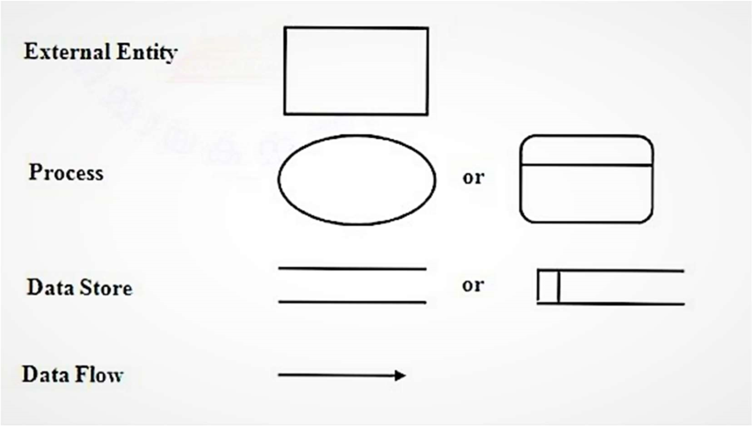

CONTEXT LEVEL 0

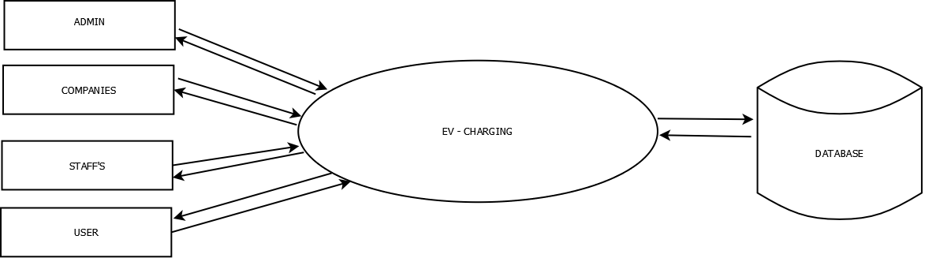

LEVEL 1 FOR ADMIN

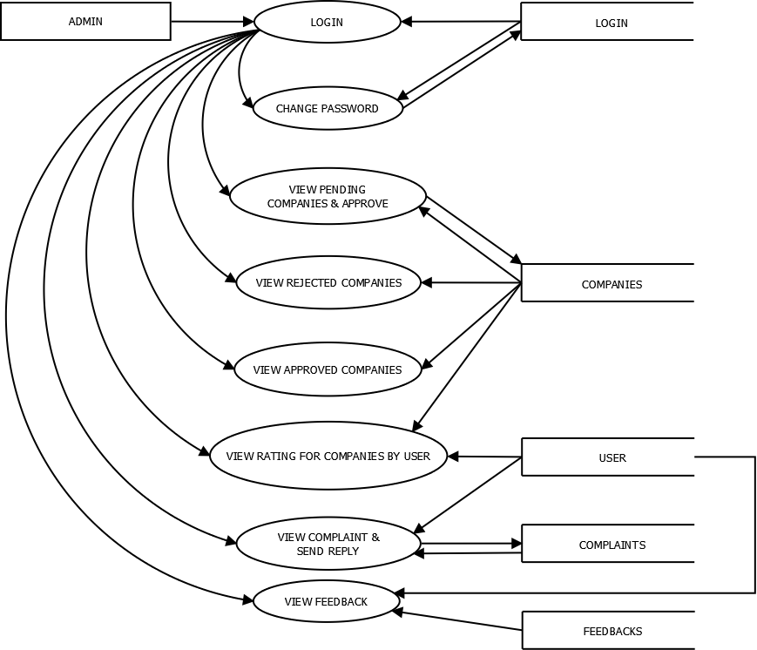

LEVEL 2 FOR COMPANY

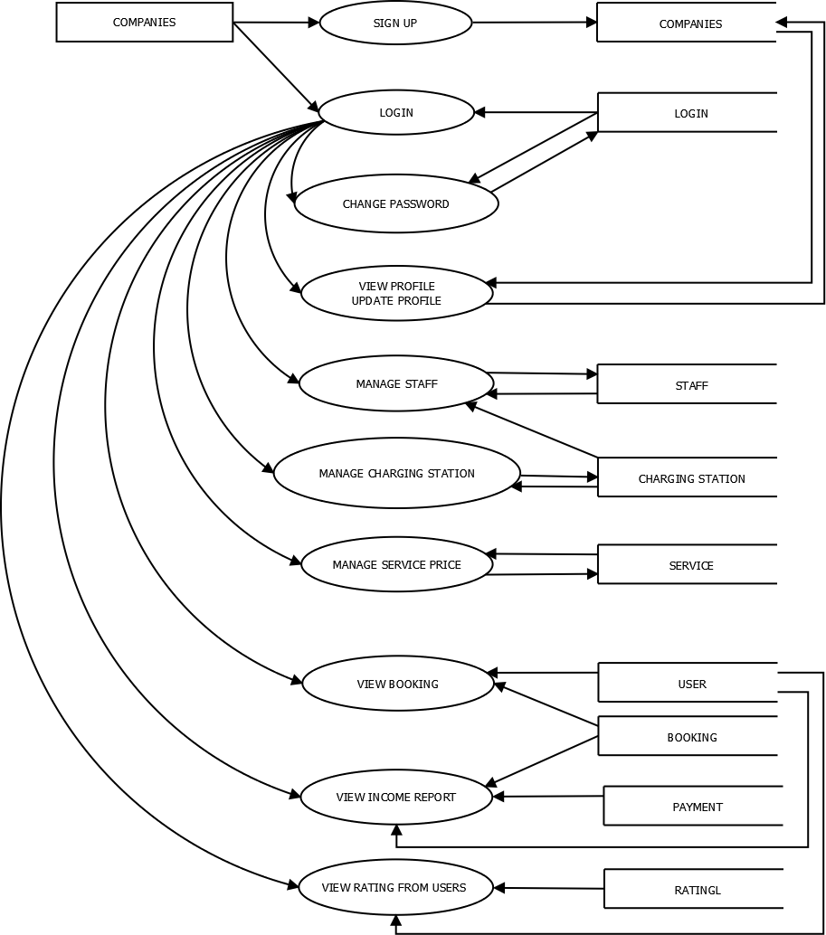

LEVEL 3 FOR STAFF

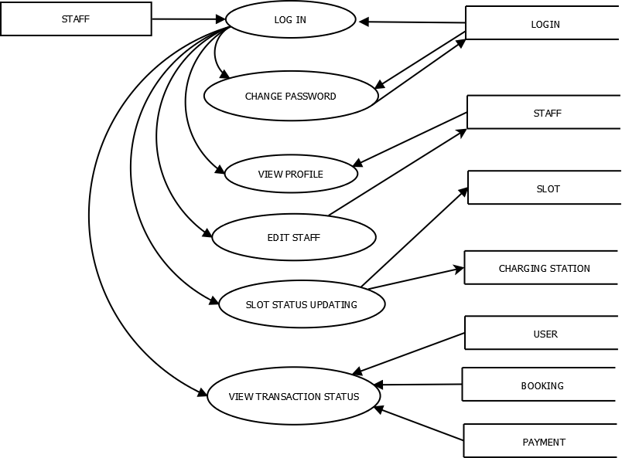

LEVEL 4 FOR USER

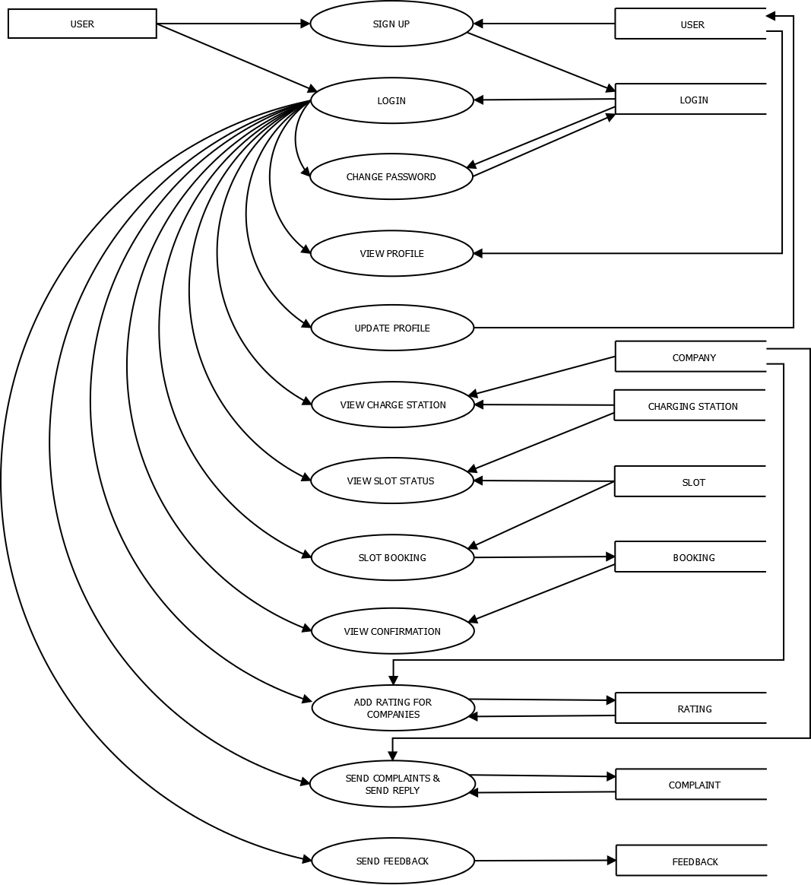

8.3 ER DIAGRAM

An entity-relationship diagram (ERD) is a data modelling technique that graphically illustrates an information system’s entities and the relationships between those entities. An ERD is a conceptual and representational model of data used to represent the entity framework infrastructure. An entity-relationship diagram (ERD) is crucial to creating a good database design. It is used as a high-level logical data model, which is useful in developing a conceptual design for databases.

An entity is a real-world item or concept that exists on its own. Entities are equivalent to database tables in a relational database, with each row of the table representing an interface of that entity.

An attribute of an entity is a particular property that describes the entity. A relationship is the association that describes the interaction between entities. Cardinality, in the context of ERD, is the number of instances of one entity that can, or must, be associated with each instance of another entity. In general, there may be oneto-one, one-to-many, or many-to-many relationships.

Steps involved in creating an ERD include:

* Identifying and defining the entities
* Determining all interactions between the entities
* Analysing the nature of interactions/determining the cardinality of the relationships
* Creating the ERD

There are three levels in the data model. They are

* Conceptual Data Model
* Logical data Model
* Physical data Model

CONCEPTUAL DATA MODEL

This ER model establishes a broad view if what should be included in the model set Conceptual data models:

* Important entities and the relationship between them.
* Do not specify attributes.
* Do not specify primary keys.

Conceptual ERDS can be used as the foundation for logical data models. They may also be used to form commonality relationships between ER models as a basis for data model integration.

LOGICAL DATA MODEL

This model contains more detail than the conceptual ER model, without regard to how information will be physically implemented in the database. Logical data models:

* Include all entities and relationships between them.
* Specify attributes for each entity.
* Specify primary key for each entity.
* Specify foreign keys, which identify the relationship between different entities.

Involve normalization, which is the process of removing redundancy in a table so that the table is easier to modify. Normalization typically occurs by dividing an entity table into two or more tables and defining relationships between the tables.

PHYSICAL DATA MODEL

The physical data model represents the process of adding information to the database. This model shows all table structures, including column name, column data type, column constraints, primary key, foreign key, and relationship between tables.

Physical data models:

* Specify all tables and columns.
* Include foreign keys to identify relationships between tables.
* May include de-normalization, depending on user requirements.
* May be significantly different from the logical data model.

Will differ depending on which DBMS (database management system) is used.

Conceptual ERD Symbols

These symbols are generally used for conceptual data models, although some aspects may spill over into logical data models. They can be found in the UML Entity Relationship and Entity Relationship shape library of lucid chart. If you don't see the shape you need, use an image file (Lucid chart supports .PNG, JPG, or .SVG import) or create your own with our existing shapes and styling options.

Entities

Entities are objects or concepts that represent important data. They are typically nouns, E.g. customer, Supervisor, location, or promotion.

Strong entities exist independently from other entity types. They always possess one or more attributes that uniquely distinguish each occurrence of the entity.

Weak entities depend on some other entity type. They don't possess unique attributes (also known as a primary key) and have no meaning in the diagram without depending on another entity. This other entity is known as the owner. Associative entities are entities that associate the instances of one or more entity types. They also contain attributes that are unique to the relationship between those entity instances.

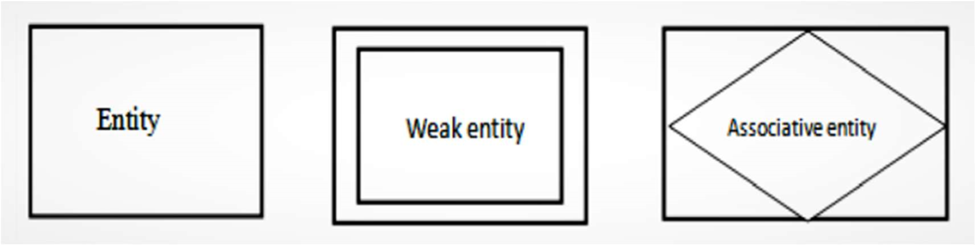

Associative entities are entities that associate the instances of one or more entity type. They also contain attributes that are unique to the relationship between those entity instances.

Relationships

Relationships are meaningful associations between or among entities. They are usually verbs, e.g. assign, associate, or track. A relationship provides useful information that could not be discerned with just the entity types.

Weak relationships, or identifying relationships, are connections that exist between a weak entity type and its owner.

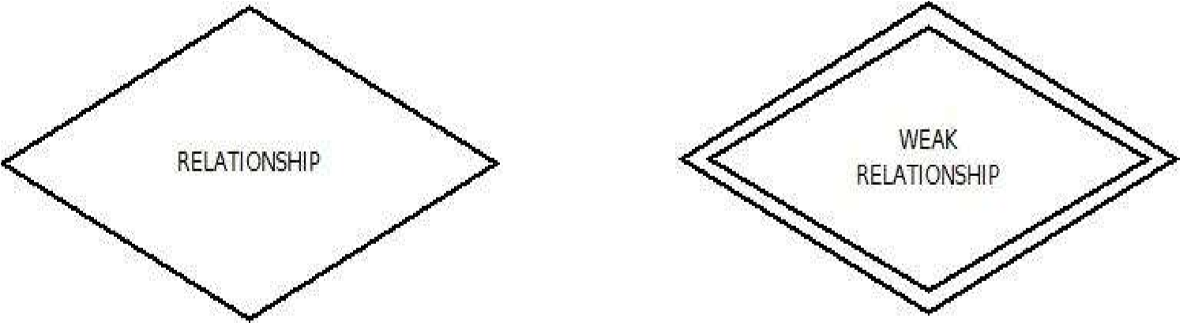

Attributes

Attributes are characteristics of an entity, a many-to-many relationship, or a one-to-one relationship.

Multi valued attributes are those that are capable of taking on more than one value.

Derived attributes are attributing whose value can be calculated from related attribute value

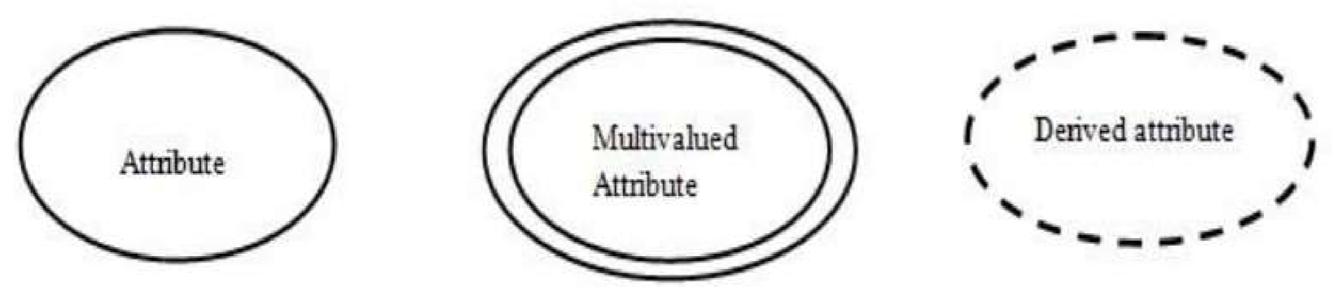

Physical ERD Symbols

The symbols below are used at the most granular level of ERDS: physical data models, although some elements are also used for logical data models.

* Tables are another way of representing entities. Fields represent attributes of the entity.
* Keys are one way to categorize attributes. A primary key is an attribute or combination of attributes that uniquely identifies one and only one instance of an entity. The primary key becomes a foreign key in any entity type to which it's related through a one-to-one or one-to-many relationship.
* Types may refer to the type of data associated with the corresponding field in a table. Types can also refer to entity types, which describe the structure of an entity; e.g., a book's entity types are author, title, and published date. Both minimum and maximum cardinality in lan easy-to-read graphic format, Lucid chart offers crow's foot notation as the preferred style.

ERD Notation

* Relationships illustrate an association between two tables. In the physical data model, relationships are represented by stylized lines.
* Cardinality and ordinarily, respectively, refer to the maximum number of times an instance in one entity can be associated with instances in the related entity, and the minimum number of times an instance in one entity can be associated with an instance in the related entity. Cardinality and ordinarily are represented by the styling of a line and its endpoint, as denoted by the chosen notation style.
* One
* Many
* 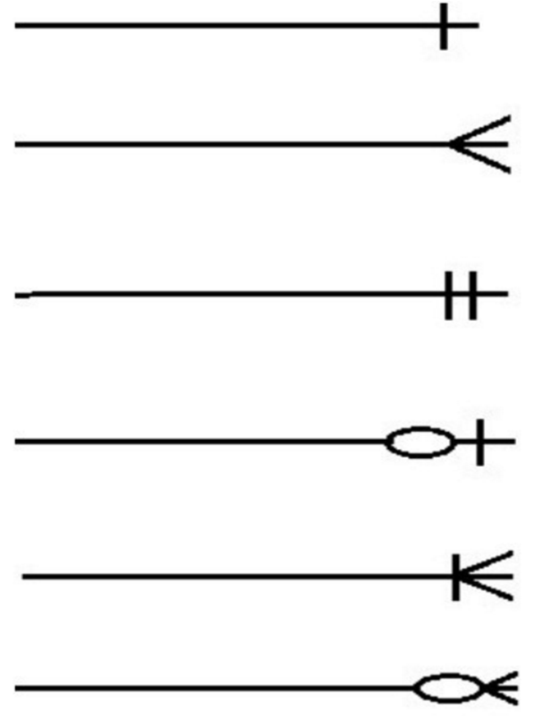One and (only one)
* Zero and More
* One or Many
* Zero or Many

ER DAIGRAM FOR EVGO

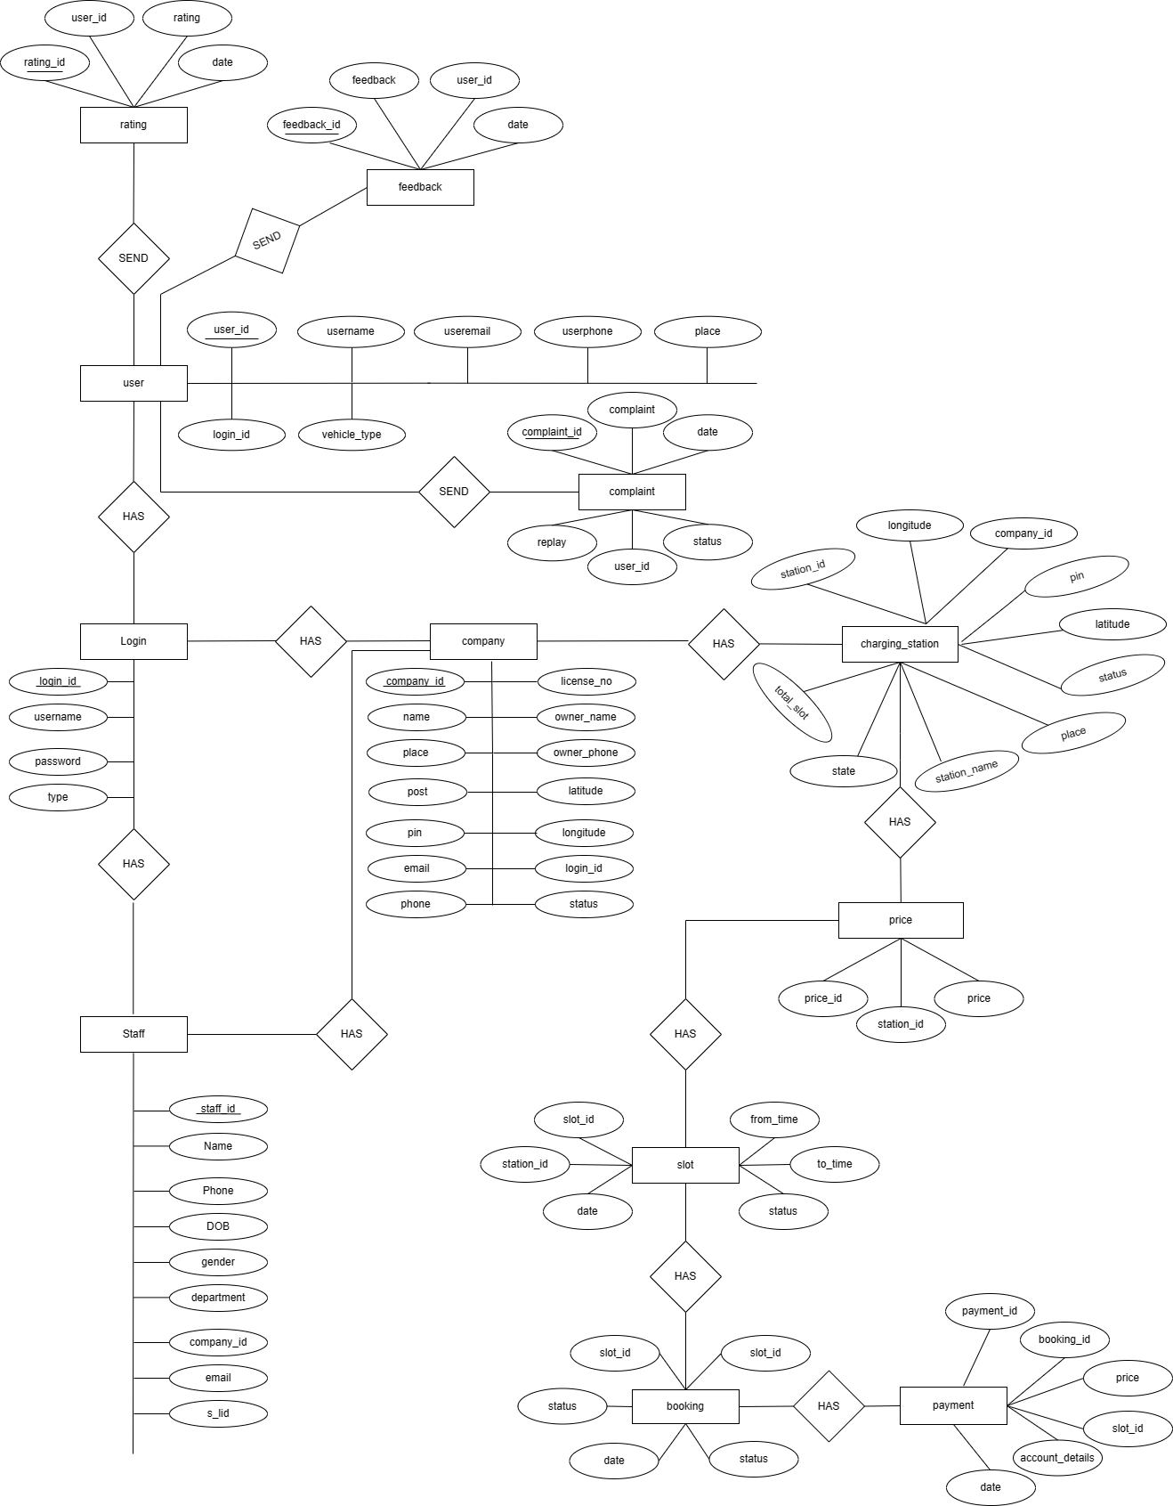

8.4 DATABASE DESIGN

Database design is the organization of data according to a database model. The designer determines what data must be stored and how the data elements interrelate. With this information, they can begin to fit the data to the database model. Database design involves classifying data and identifying interrelationships.

One of the most important tasks involved in the design phase is the design of data storage. A database is a collection of interrelated data stored with minimum redundancy to serve many users quickly and efficiently. The general objective is to make access easy, quick inexpensive and flexible for the user. Relationships are established between the data items and unnecessary data items removed. Normalization is done to get an internal consistency of data and to have minimum redundancy and maximum stability. This ensures minimizing data storage required, minimizing chances of data inconsistencies and optimizing for updates. The MYSQL database has been chosen for developing the relevant database. The database design procedure transforms the information domain model created during the analysis into tables that will be required to implement the software or system. A database is a collection of data. Some of the major task in computer system is to store and manage data. To handle these tasks a specialized computer program known as DBMS is needed. A DBMS stores, process and retrieves data efficiently. The database design is made-up of two levels.

1. Conceptual Level
2. Normalization
3. CONCEPTUAL LEVEL

This level represents the major data objects and relationship between them.

Conceptual level describes the essential feature of the system data.

1. NORMALIZATION

Normalization Criteria: -

Normalization is the process of decomposing a set of relations with anomalies to produce smaller and well-structured relations that contain minimum redundancy. It is a formal process of deciding which attributes should be grouped together in a relation. The purpose of normalization is to make table as simple as possible. Normalization carried out in the system for following reasons:

* + - To structure the data. So that there is no repetition of data, this helps in saving space.
    - To permit simple retrieval of data in response to query and request.
    - To simplify maintenance of data through updates, insertion and deletion.
    - To reduce the need to restructures or recognize data which new application requirements arise?

Primary key is assigned for this purpose. The primary key fields in almost all tables help to ease the search and improve efficiency.

The different normal forms applied during the database design are given below.

* + - First Normal Form (1NF)
    - Second Normal Form (2NF)
    - Third Normal Form (3NF)

First Normal Form: -

Each row and column must have an single value with no repeating values.

Second Normal Form: -

Second Normal form (2NF) is based on the concept of functional dependency. A relation R is in 2NF if it is in 1NF and every non key attribute A of R is fully dependent on the primary key. That is, relation is said to be in 2NF if each attribute A in R meets one of the following criteria:

* + 1. It appears in the primary key.
    2. It is fully functionally dependent on the primary key. The tables designed in this database contain a primary key for uniquely identifying each record in the table.

Third Normal Form: -

No non-key column can depend on another non-key column.

8.5 TABLE DESIGN

* + 1. Login
    2. Bank
    3. Booking
    4. Charging Station
    5. Company
    6. Complaint
    7. Feedback
    8. Payment
    9. Price
    10. Rating
    11. Signup
    12. Slot
    13. Staff
    14. User

BANK

|  |  |  |  |
| --- | --- | --- | --- |
| Field Name | Data Type | Size | Constrain |
| bank_Id | Int | 11 | Primary key |
| bank_name | Varchar | 30 |  |
| Ifsc_code | Varchar | 34 |  |
| balance | Varchar | 22 |  |
| ac_no | Varchar | 21 |  |

BOOKING

|  |  |  |  |
| --- | --- | --- | --- |
| Field Name | Data Type | Size | Constrain |
| booking_Id | Int | 11 | Primary key |
| slot_id | Int | 11 |  |
| user_id | Int | 11 |  |
| date | Varchar | 20 |  |
| status | Varchar | 30 |  |

CHARGING STATION

|  |  |  |  |
| --- | --- | --- | --- |
| Field Name | Data Type | Size | Constrain |
| station_id | Int | 11 | Primary key |
| total_slot | Varchar | 20 |  |
| station_name | Varchar | 25 |  |
| place | Varchar | 30 |  |
| latitude | Varchar | 40 |  |
| longitude | Varchar | 40 |  |
| pin | bigint | 6 |  |
| state | Varchar | 30 |  |
| status | Varchar | 20 |  |
| company_id | Varchar | 11 |  |

COMPANY

|  |  |  |  |
| --- | --- | --- | --- |
| Field Name | Data Type | Size | Constrain |
| company_id | Int | 11 | Primary key |
| name | Varchar | 30 |  |
| place | Varchar | 20 |  |
| post | Varchar | 20 |  |
| pin | Varchar | 25 |  |
| email | Varchar | 30 |  |
| phone | bigint | 15 |  |
| license_number | Varchar | 20 |  |
| owner_name | Varchar | 30 |  |
| owner_phone | Varchar | 15 |  |
| latitude | Varchar | 20 |  |
| longitude | Varchar | 20 |  |
| login_id | int | 11 |  |
| status | Varchar | 55 |  |

COMPLAINT

|  |  |  |  |
| --- | --- | --- | --- |
| Field Name | Data Type | Size | Constrain |
| complaint_Id | Int | 11 | Primary key |
| complaint | Varchar | 60 |  |
| date | Date |  |  |
| user_id | int | 11 |  |
| reply | Varchar | 30 |  |
| status | Varchar | 55 |  |

FEEDBACK

|  |  |  |  |
| --- | --- | --- | --- |
| Field Name | Data Type | Size | Constrain |
| feedback_Id | Int | 11 | Primary key |
| feedback | Varchar | 50 |  |
| date | Date |  |  |
| user_id | int | 11 |  |



LOGIN

|  |  |  |  |
| --- | --- | --- | --- |
| Field Name | Data Type | Size | Constrain |
| login_Id | Int | 11 | Primary key |
| username | Varchar | 30 |  |
| password | Varchar | 20 |  |
| type | Varchar | 20 |  |

PAYMENT

|  |  |  |  |
| --- | --- | --- | --- |
| Field Name | Data Type | Size | Constrain |
| payment_Id | Int | 11 | Primary key |
| booking_id | Int | 11 |  |
| user_id | Int | 11 |  |
| price | int | 11 |  |
| slot_id | Int | 11 |  |
| account_detials | Varchar | 40 |  |
| date | date |  |  |

PRICE

|  |  |  |  |
| --- | --- | --- | --- |
| Field Name | Data Type | Size | Constrain |
| price_Id | Int | 11 | Primary key |
| station_id | int | 11 |  |
| price | Varchar | 30 |  |

RATING

|  |  |  |  |
| --- | --- | --- | --- |
| Field Name | Data Type | Size | Constrain |
| rating_Id | Int | 11 | Primary key |
| user_id | Int | 11 |  |
| rating | Varchar | 50 |  |
| date | date |  |  |

SIGNUP

|  |  |  |  |
| --- | --- | --- | --- |
| Field Name | Data Type | Size | Constrain |
| signup_Id | Int | 11 | Primary key |
| username | Varchar | 30 |  |
| password | Varchar | 30 |  |
| type | Varchar | 30 |  |

SLOT

|  |  |  |  |
| --- | --- | --- | --- |
| Field Name | Data Type | Size | Constrain |
| slot_Id | Int | 11 | Primary key |
| Station_id | Int | 11 |  |
| date | date |  |  |
| fromtime | Varchar | 20 |  |
| totime | Varchar | 20 |  |
| status | Varchar | 20 |  |

STAFF

|  |  |  |  |
| --- | --- | --- | --- |
| Field Name | Data Type | Size | Constrain |
| staff_Id | Int | 11 | Primary key |
| name | Varchar | 30 |  |
| phone | Varchar | 15 |  |
| dob | date |  |  |
| gender | Varchar | 20 |  |
| company_id | Int | 20 |  |
| email | Varchar | 30 |  |
| s_lid | Int | 11 |  |

USER

|  |  |  |  |
| --- | --- | --- | --- |
| Field Name | Data Type | Size | Constrain |
| user_Id | Int | 11 | Primary key |
| username | Varchar | 30 |  |
| useremail | Varchar | 30 |  |
| userphone | Varchar | 20 |  |
| place | Varchar | 30 |  |
| login_id | Int | 20 |  |
| vehicle_type | Varchar | 30 |  |

**8.6 DATABASE STRUCTURE**

A modern database management system is a complex software system that leverages many sophisticated algorithms, for example to evaluate relational operations, to provide efficient access to data, to manage the buyer pool, and to move data between disk and main memory. In this chapter, we have shown how many of the data structures that were introduced in earlier parts of this book including a few ones such as histograms, LOBs, and disk paged, are being used in real world applications. however, as we have noted in the introduction, our coverage of the data structures that are part of a DBMS is not meant to be exhaustive since a complete treatment would have easily exceeded the scope of this chapter. Furthermore, as the functionality of a DBMS must continuously grow in order to support new applications, so does the set of data structures that must be designed to efficiently manage the underlying data (e.g., spatiotemporal data, XML, biomedical data). Many of these new data structure challenges are being actively studied in the database research communities today and are likely to form a basis for tomorrow’s systems.

**8.7 INPUT DESIGN**

Input design is a part of overall design, which requires careful attributes. Input design is a process of converting user-oriented input into computer-based format. This input to the system is provided using Speech to Text. The goal of designing input data is to make entry as easy, logical and free from errors. Computers require necessary data for their functioning, hence input design become an essential part of computer-oriented information system. In input design user-oriented inputs are converted into computer-based formats. Inputs are of two types in a computer system.

1. Input document used in a system
2. Input screens

The goal of designing input data is to make data entry easy, logical and free from error as possible. Inputs are raw data that are accepted from the system and are processed to produce the output. The input records must be validated, edited, organized and accepted by the system before being processed to produce the output. We use some data entry screens for inputting different data. Input screens messages and careful programming can reduce input as errors to some extent.

Input design features can ensure the reliability of the system and determines how efficiently the user can interact with the system. A good input screen is clear and free from irrelevant information. Entered data must be checked for their accuracy and detection of errors. All the data entry screens should be of interactive nature so that the user can directly input data according to prompt messages. The input design determines whether the user can interact directly with the computer. Interactive input screens ensure the reliability and accuracy of the system.

The goal of designing input data is to make it free from logical errors. The input data is also used for easy calculation of necessary functions. The inputted data is compared with the commands for doing the functions. Input Specifications describe the way data enter the system for Processing.

The design of the input should have:

* Effectiveness
* Accuracy
* Simplicity

**8.8 OUTPUT DESIGN**

The output is the most important and direct source of information to the user. Efficient intelligible output design improves the system relationship with the user and helps in decision making.

One of the most important features of the system for users is the output it produces. Output design should improve the system relationship with the user it produces and helps in decision making. Considering the future use of the output required and depending on the nature, they are produced as voice to the users by using text to speech.

**8.9 USER INTERFACE DESIGN**

User Interface (UI) Design focuses on anticipating what users might need to do and ensuring that the interface has elements that are easy to access, understand, and use to facilitate those actions. UI brings together concepts from interaction design, visual design, and information architecture.

Choosing Interface Elements

Users have become familiar with interface elements acting in a certain Way, so try to be consistent and predictable in your choices and their layout. Doing so Will help with task completion, efficiency, and satisfaction. Interface elements include but are not limited to:

* Input Controls: buttons, text fields, checkboxes, radio buttons, dropdown lists, list boxes, toggles, date field
* Informational Components: tooltips, icons, progress bar, notifications, message boxes, modal windows
* Navigational Components: breadcrumb, slider, search field, pagination, slider, tags, icons
* There are times when multiple elements might be appropriate for displaying content. When this happens, it`s important to consider the trade-offs. For example, sometimes elements that run help save you space, put more of a burden on the user mentally by forcing them to guess what is within the dropdown or what the element might be.

**Best Practices for Designing an Interface**

Everything stems from knowing your users, including understanding their goals, skills, preferences, and tendencies. Once you know about your user, make sure to consider the following when designing your interface:

* Keep the interface simple. The best interfaces are almost invisible to the user. They avoid unnecessary elements and are clear in the language they use on labels and in messaging.
* Create consistency and use common UI elements. By using common elements in your UI, users feel more comfortable and are able to get things done more quickly. lt is also important to create patterns in language, layout and design throughout the site to help facilitate efficiency. Once a user learns how to do something, they should be able to transfer that skill to other parts of the site.
* Be purposeful in page layout. Consider the spatial relationships between items on the page and structure the page based on importance. Careful placement of items can help draw attention to the most important pieces of information and can aid scanning and readability.
* Strategically use colour and texture. You can direct attention toward or redirect attention away from items using colour, light, contrast, and texture to your advantage. Use typography to create hierarchy and clarity. Carefully consider how you use typeface. Different sizes, fonts, and arrangement of the text to help increase scalability, legibility and readability

Make sure that the system communicates what's happening. Always inform your users of location, actions, changes in state, or errors. The use of various Ul elements to communicate status and, if necessary, next steps can reduce frustration for your user. Think about the defaults. By carefully thinking about and anticipating the goals people bring to you site; you can create defaults that reduce the burden on the user. This becomes particularly important when it comes to form design where you might have an opportunity to have some fields pre-chosen or filled out.

**SOFTWARE TESTING**

Testing is the process of checking whether the developed system is working according to the original objectives and requirements. Software testing is essential for correcting errors. Otherwise the project is not said to be complete. The system should be tested experimentally with test data so as to ensure that the system works according to the required specification. When the system is found working, test it with actual data and check performance. Software testing is a set of processes aimed at investigating, evaluating and ascertaining the completeness and quality of computer software. Software testing ensures the compliance of a software product in relation with regulatory, business, technical, functional and user requirements. Software testing is also known as application testing.

Software testing is primarily a broad process that is composed of several interlinked processes. The primary objective of software testing is to measure software health along with its completeness in terms of core requirements. Software testing involves examining and checking software through different testing processes. The objectives of these processes can include:

* Verifying software completeness in regards to functional/business requirements
* Identifying technical bugs/errors and ensuring the software is error-free

Assessing usability, performance, security, localization, compatibility and installation The tested software must pass each of the tests in-order to be considered complete or fit for use. Some of the different types of software testing methods include white box testing, black box testing and grey box testing. Moreover, the software can be tested as a whole, in components/units or within a live system.

**Need for Testing**

Testing was essential for the following reasons:

* Existence of program defects of inadequacies
* The software behaviour as intended by its designer
* Conformance with requirement specification/user needs.
* Asses the operational reliability of the system.
* Reflect the frequency of actual user inputs.
* Find the fault, which caused the output anomaly.
* Checks for detect flows and deficiencies in the requirements.
* Check whether the software is operationally useful.
* Exercise program using data like the real data processed by the program.

Software testing passes through different levels of phases:

* Unit Testing
* Integration Testing
* System Testing
* Acceptance Testing
* White Box Testing
* Black Box

**9.1 UNIT TESTING**

During this first round of testing, the program is submitted to assessments that focus on specific units or components of the software to determine whether each one is fully functional. The main aim of this endeavour is to determine whether the application functions as designed. In this phase, **a unit can refer to a function, individual program or even a procedure**, and a White box Testing method is usually used to get the job done. One of the biggest benefits of this testing phase is that it can be run every time a piece of code is changed, allowing issues to be resolved as quickly as possible. It’s quite common for software developers to perform unit tests before delivering software to testers for formal testing.

**9.2 INTEGRATION TESTING**

Integration testing allows individuals the opportunity to combine all of the units within a program and test them as a group. This testing level is designed to **find interface defects between the modules/functions.** This is particularly beneficial because it determines how efficiently the units are running together. Keep in mind that no matter how efficiently each unit is running, if they aren’t properly integrated, it will affect the functionality of the software program. In order to run these types of tests, individuals can make use of various testing methods, but the specific method that will be used to get the job done will depend greatly on the way in which the units are defined.

**9.3 SYSTEM TESTING**

System testing is the first level in which **the complete application is tested as a whole**. The goal at this level is to evaluate whether the system has complied with all of the outlined requirements and to see that it meets Quality Standards. System testing is undertaken by independent testers who haven’t played a role in developing the program. This testing is performed in an environment that closely mirrors production. System Testing is very important because it verifies that the application meets the technical, functional, and business requirements that were set by the customer.

**9.4 ACCEPTANCE TESTING**

The final level, Acceptance testing (or User Acceptance Testing), is conducted to **determine whether the system is ready for release**. During the Software development life cycle, requirements changes can sometimes be misinterpreted in a fashion that does not meet the intended needs of the users. During this final phase, the user will test the system to find out whether the application meets their business’ needs. Once this process has been completed and the software has passed, the program will then be delivered to production.

**9.5 WHITE BOX TESTING**

White box testing (also known as Clear Box Testing, Open Box Testing, Glass Box Testing, Transparent Box Testing, Code-Based Testing or Structural Testing) is a software testing method in which the internal structure/design/implementation of the item being tested is known to the tester. The tester chooses inputs to exercise paths through the code and determines the appropriate outputs. Programming know-how and the implementation knowledge is essential. White box testing is testing beyond the user interface and into the nitty-gritty of a system.

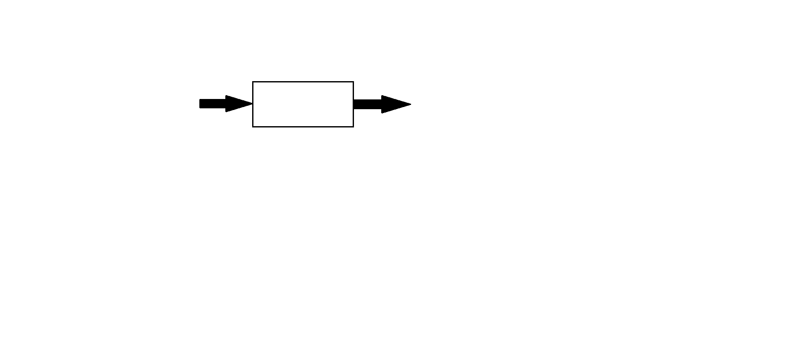

This method is named so because the software program, in the eyes of the tester, is like a white/transparent box; inside which one clearly sees.

White Box Testing method is applicable to the following levels of software testing:

* Unit Testing: For testing paths within a unit.
* Integration Testing: For testing paths between units.
* System Testing: For testing paths between subsystems.

However, it is mainly applied to Unit Testing.

**9.6 BLACK BOX TESTING**

Black Box Testing, also known as Behavioural Testing, is a software testing method in which the internal structure/design/implementation of the item being tested is not known to the tester.

These tests can be functional or non-functional, though usually functional.

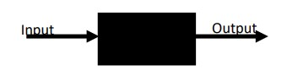

This method is named so because the software program, in the eyes of the tester, is like a black box; inside which one cannot see. This method attempts to find errors in the following categories:

* Incorrect or missing functions
* Interface errors
* Errors in data structures or external database access
* Behaviour or performance errors
* Initialization and termination errors.

Black Box testing method is applicable to the following levels of software testing:

* Integration Testing
* System Testing
* Acceptance Testing

**10. SCREENSHOTS**

LOGIN WEBPAGE

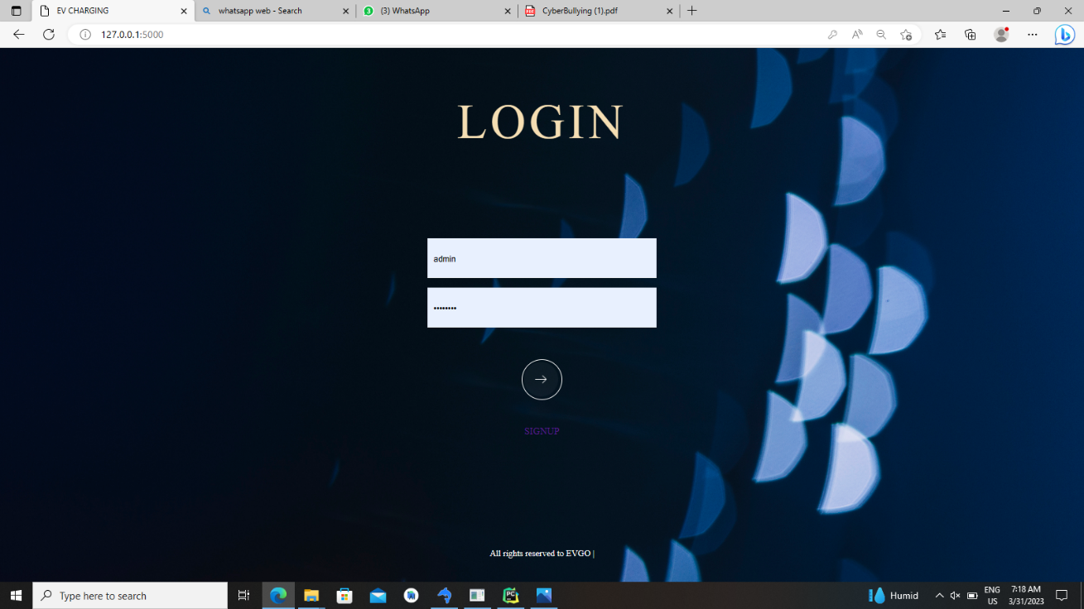

ADMIN HOME

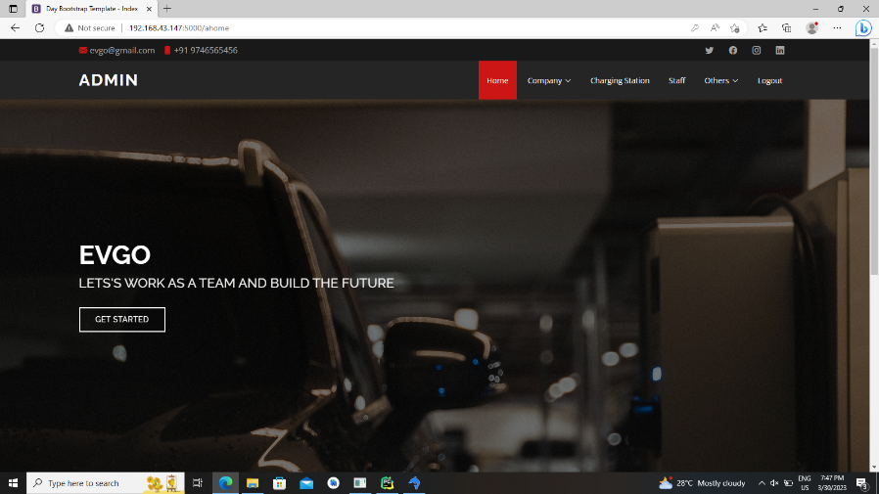

ADMIN VIEW COMPANY

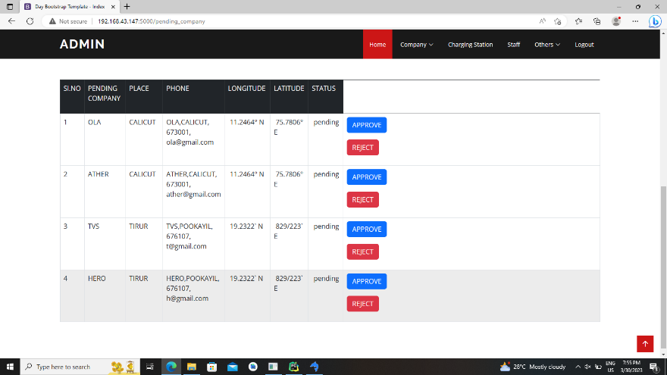

ADMIN VIEW APPROVED COMPANY

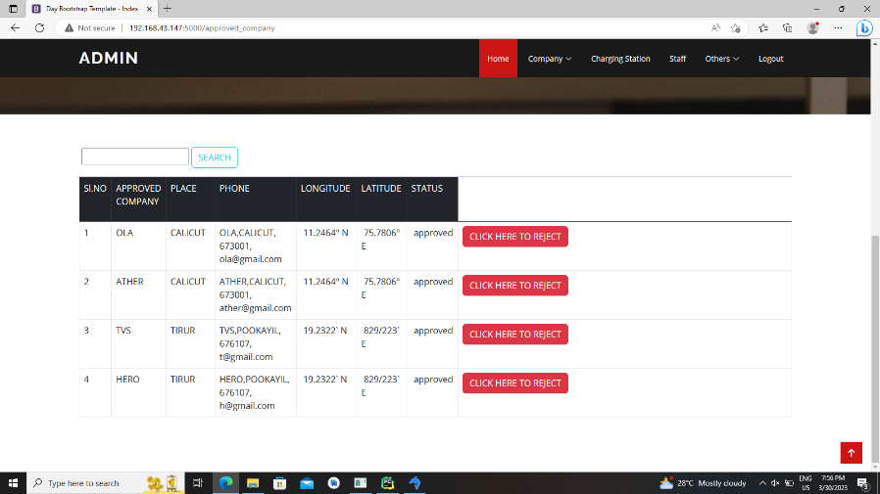

ADMIN VIEW REJECTED COMPANY

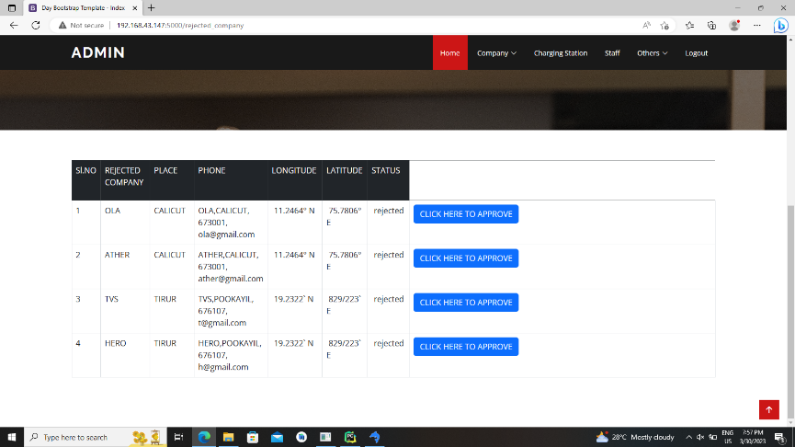

ADMIN VIEW USER RATING

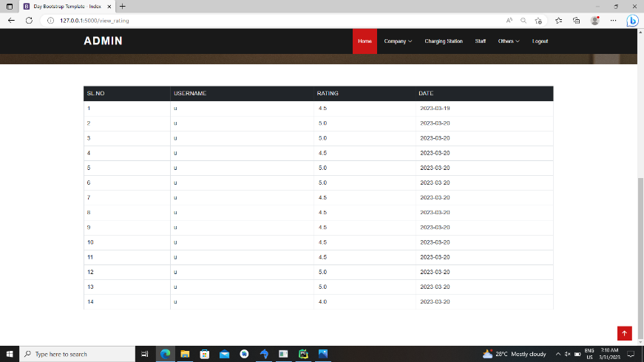

ADMIN VIEW COMPLAINT AND REPLY

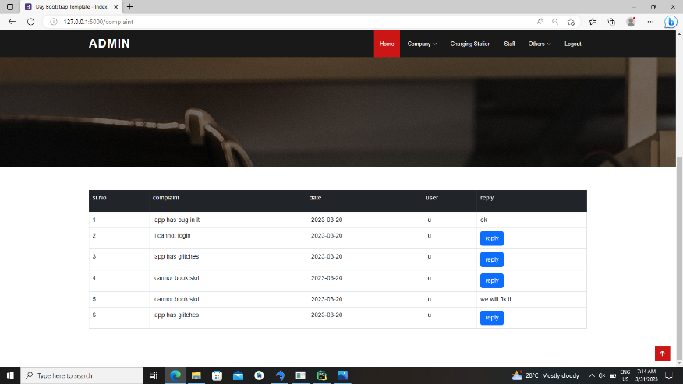

ADMIN VIEW FEEDBACK

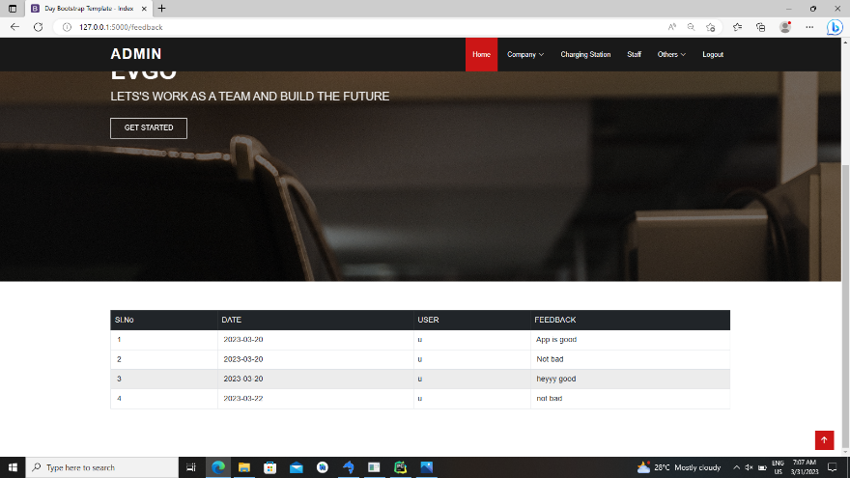

ADMIN CHANGE PASSWORD

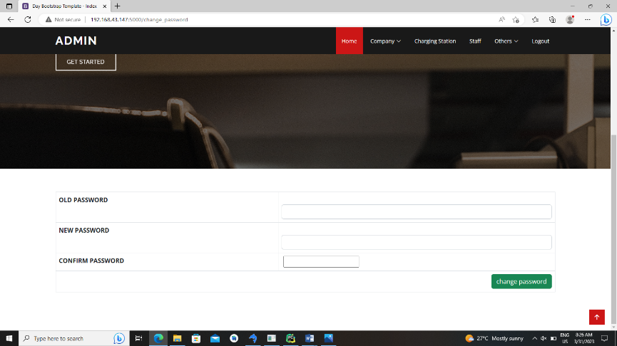

COMPANY SIGNUP

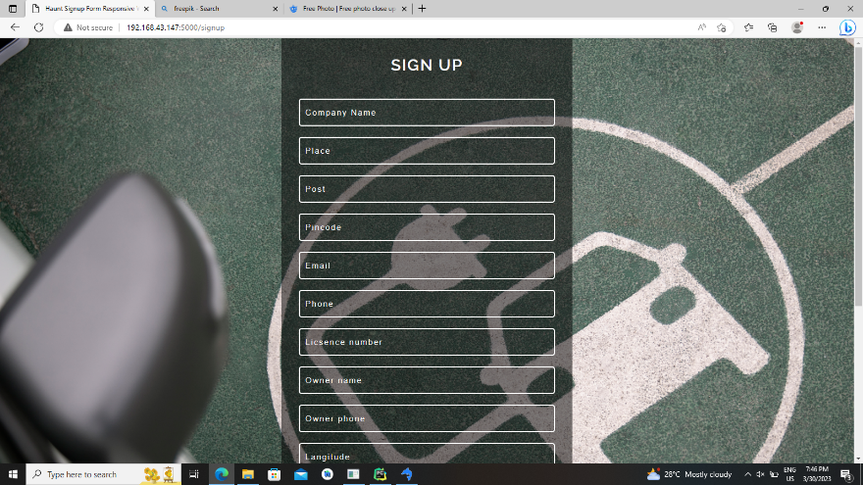

COMPANY HOME

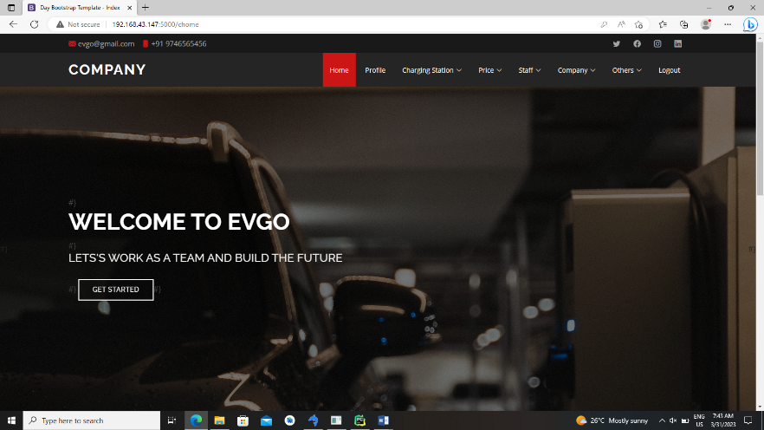

COMPANY CHANGE PASSWORD

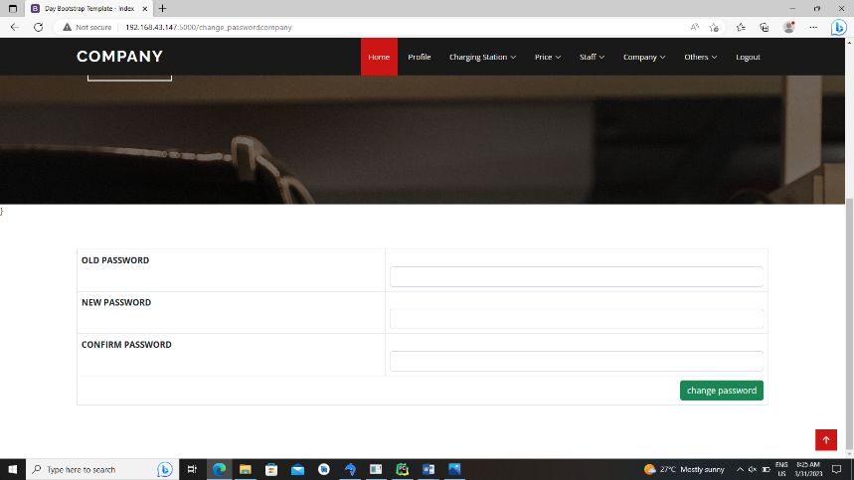

COMPANY VIEW PROFILE

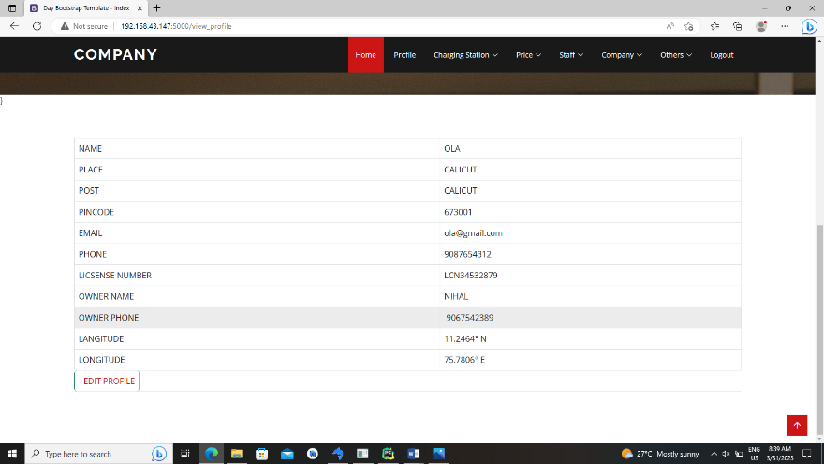

COMPANY UPDATE PROFILE

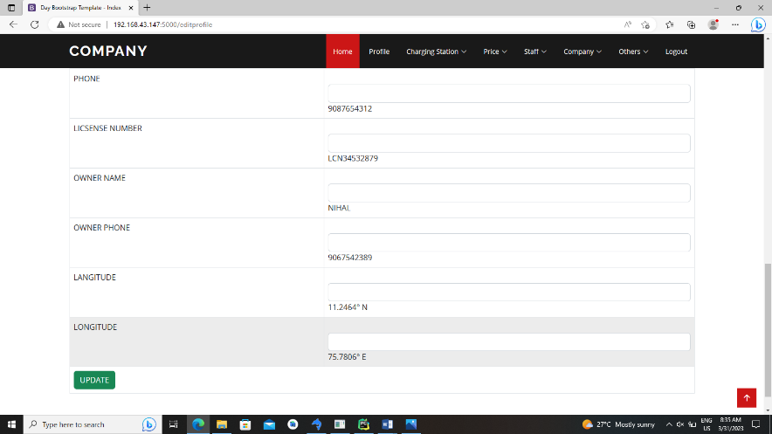

COMPANY VIEW STAFF

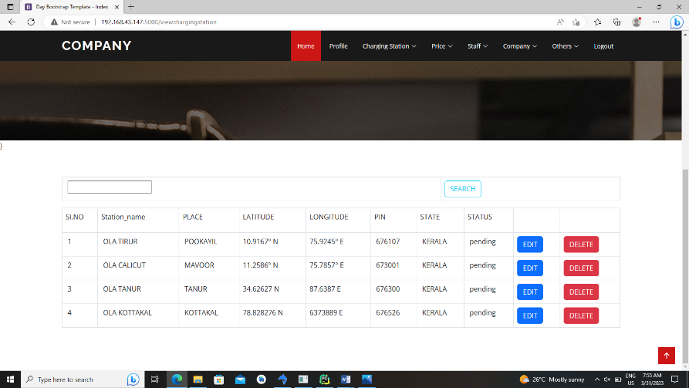

COMPANY ADD STAFF

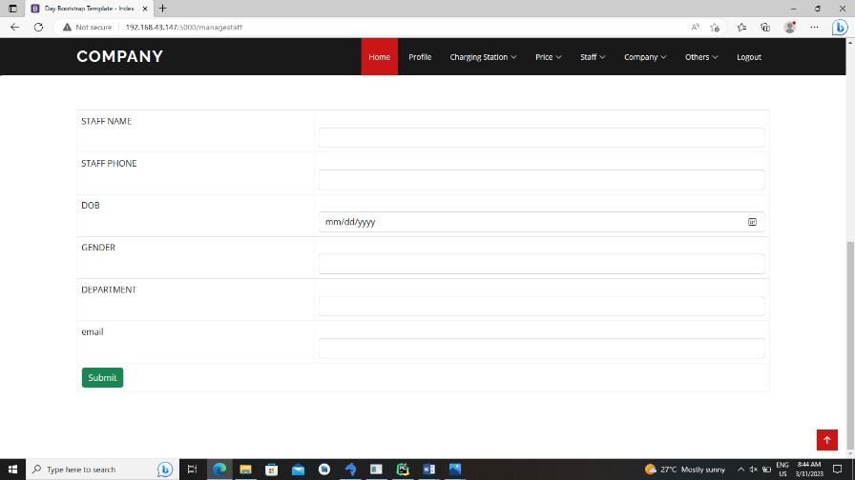

COMPANY ADD CHARGING PRICE

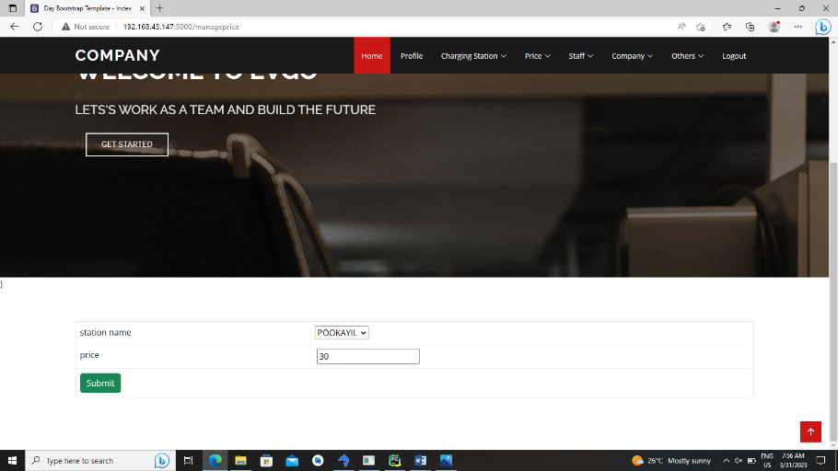

COMPANY VIEW BOOKING

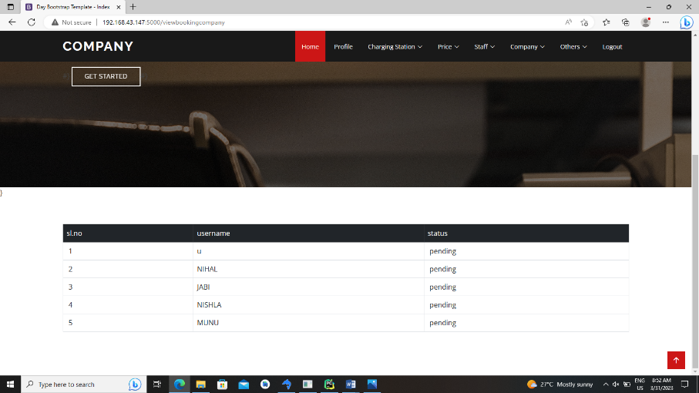

COMPANY VIEW INCOME REPORT

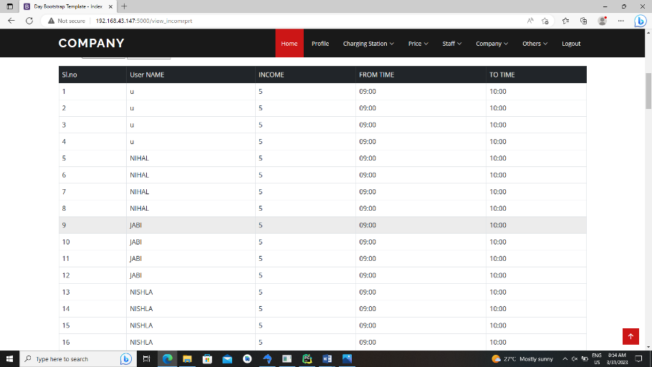

COMPANY VIEW CUSTOMER RATING

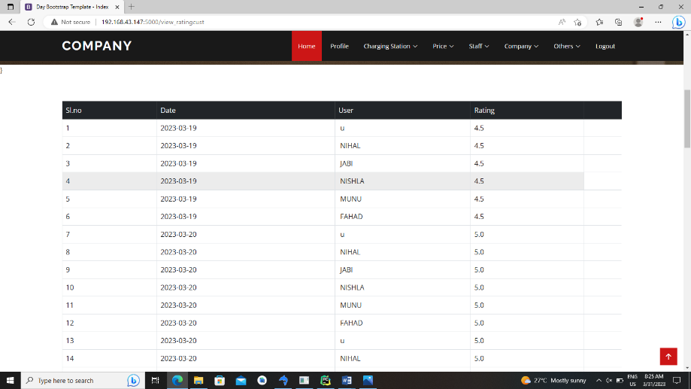

STAFF HOME

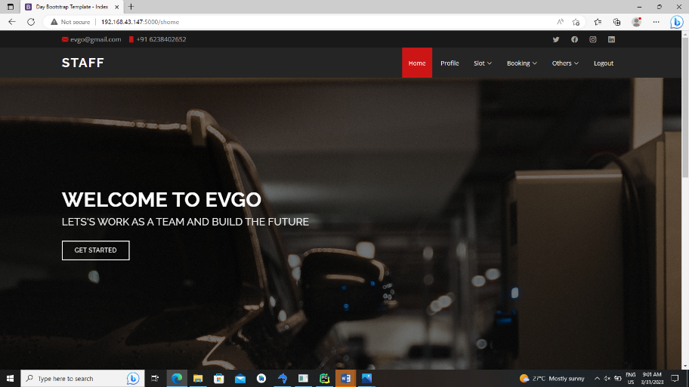

STAFF CHANGE PASSWORD

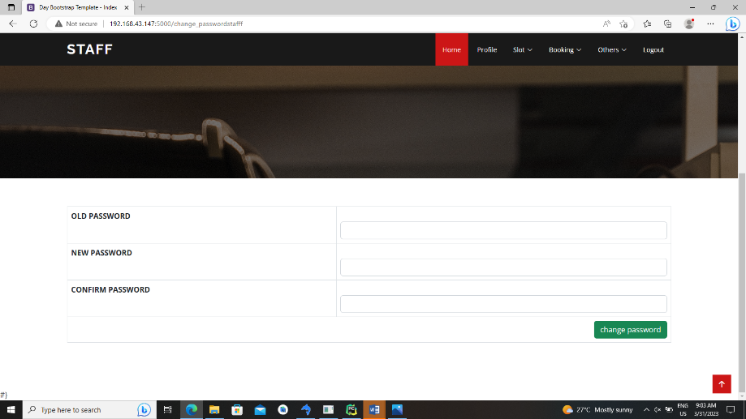

STAFF VIEW PROFILE

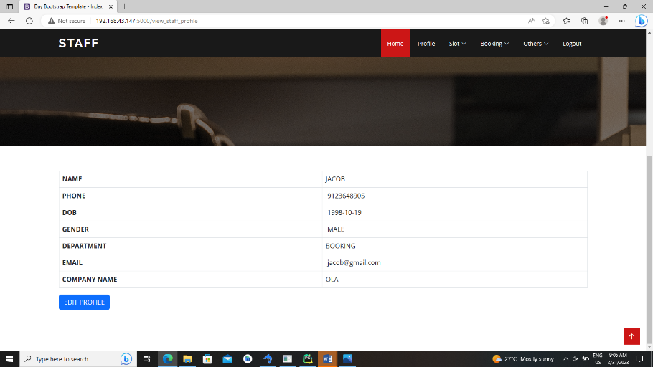

STAFF EDIT PROFILE

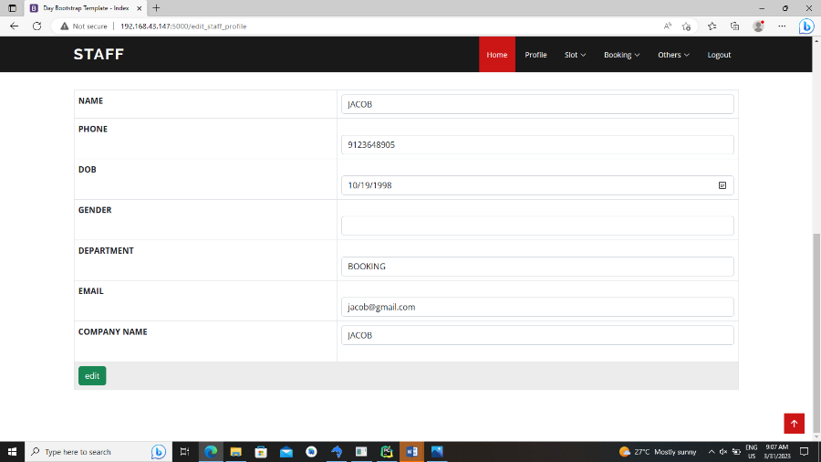

STAFF ADD SLOT

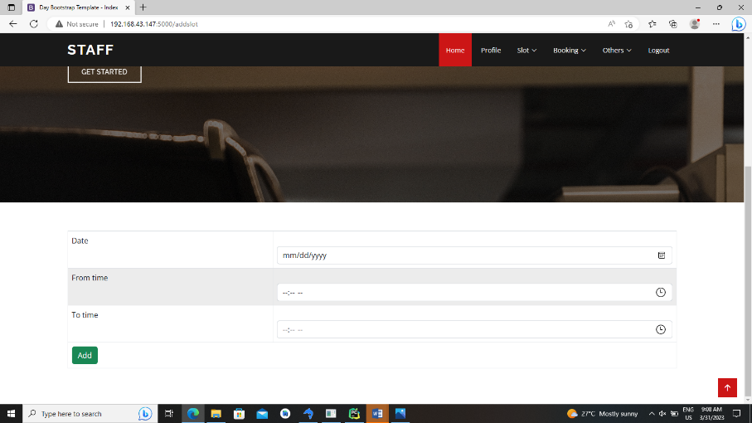

STAFF VIEW AND UPDATE SLOT

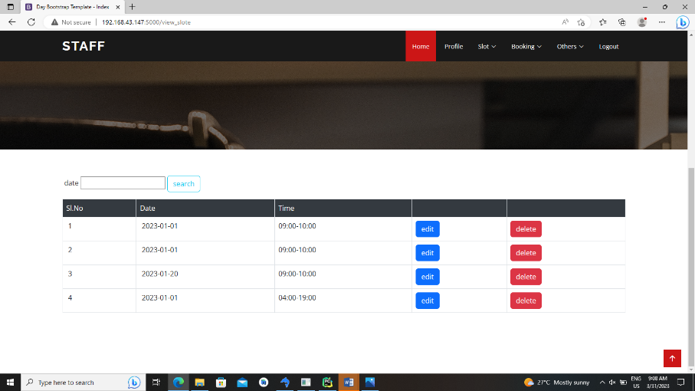

STAFF VIEW TRANSACTIONS

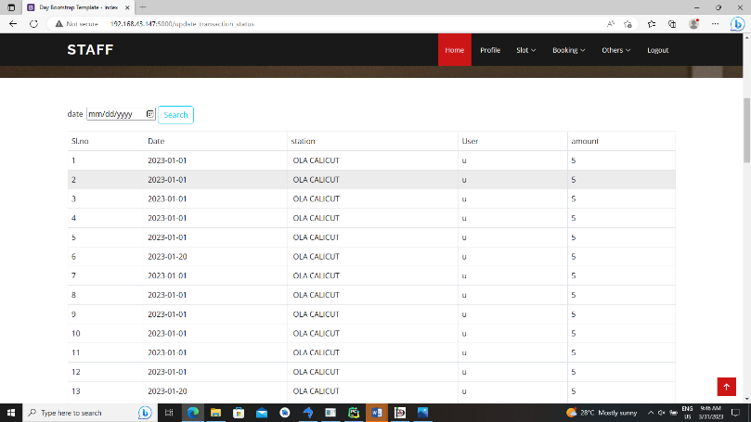

USER LOGIN PAGE-USER

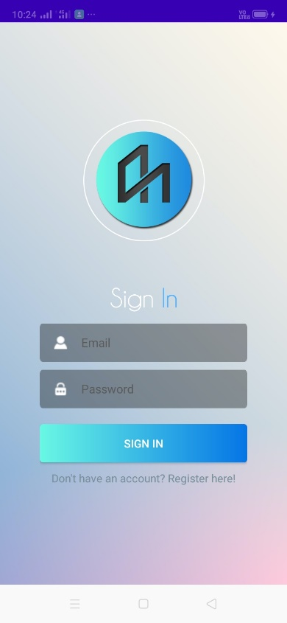

USER SIGNUP

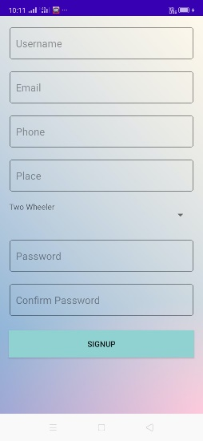

USER HOME

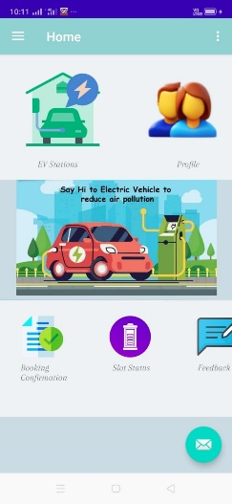

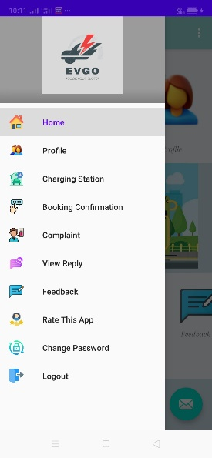

USER CHANGE PASSWORD

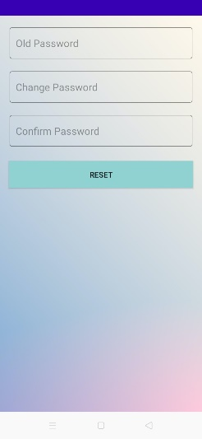

USER VIEW PROFILE

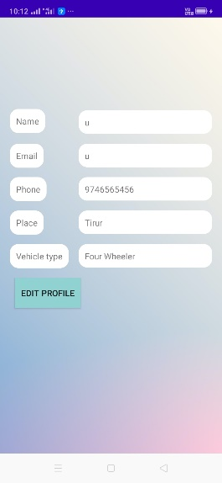

USER EDIT PROFILE

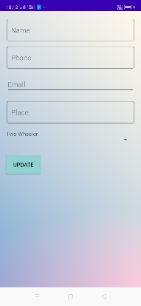

USER VIEW CHARGING STATIONS

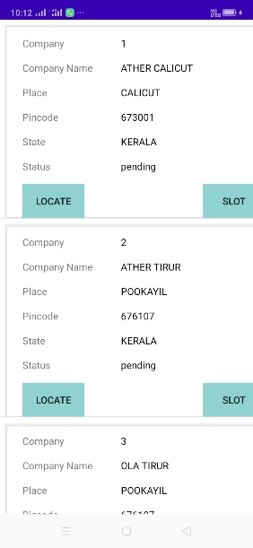

USER BOOK SLOT

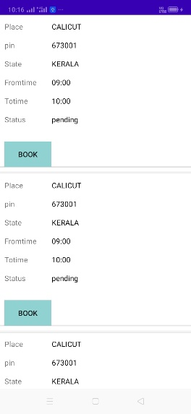

USER MAKING PAYMENT

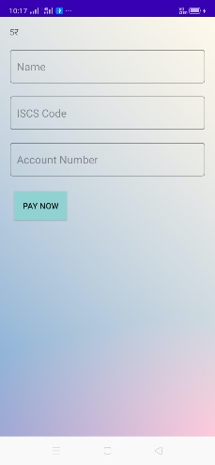

USER BOOKING CONFIRMATION

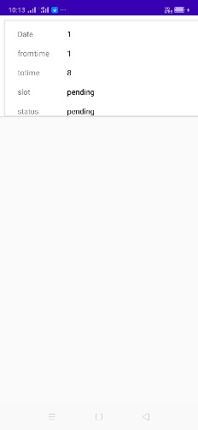

USER RATING



USER COMPLAINT



USER VIEW REPLY

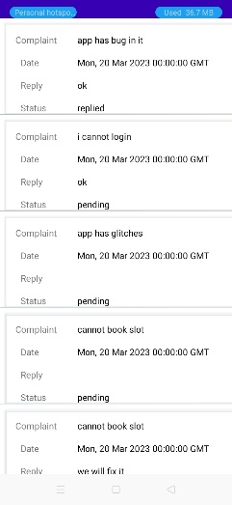

USER FEEDBACK



**11. CONCLUSION**

In conclusion, an EVGO slot booking app is an excellent solution for managing the charging process of electric vehicles. It allows EV drivers to reserve a charging slot at their convenience, thus eliminating the need to wait in long queues or drive around in search of an available charging station. Additionally, the app can provide real-time information on the availability of charging stations and the status of the slot booked. This helps to optimize the use of charging infrastructure and ensures that EVs are charged efficiently. Overall, an electric charging slot booking app is a valuable tool for EV drivers and charging station operators alike, contributing to the growth and sustainability of the electric vehicle industry.

11.1 Future Enhancement

There are several future enhancements that can be made to an electric charging slot booking app to improve its functionality and user experience. Here are a few:

1. Integration with renewable energy sources: The app could be enhanced to show charging stations that use renewable energy sources such as solar, wind, or hydroelectric. This will allow users to make more environmentally conscious choices while charging their EVs.
2. Dynamic pricing: The app could incorporate dynamic pricing, where the cost of charging varies based on the demand and supply of the charging stations. This will encourage users to charge their EVs during off-peak hours, reducing strain on the power grid during peak hours.
3. Integration with payment wallets: The app could integrate with payment wallets like PayPal or Apple Pay, allowing users to make cashless transactions easily.
4. Predictive maintenance: The app could use data analytics to predict the need for maintenance of charging stations, thereby reducing downtime and improving the reliability of the charging infrastructure.
5. In-app chat support: The app could include an in-app chat support feature, allowing users to reach out to customer service agents quickly and efficiently for assistance with any issues they encounter while using the app.

By incorporating these enhancements, an electric charging slot booking app can offer a more comprehensive and user-friendly experience, further promoting the adoption of electric vehicles and sustainable transportation.

12. BIBLIOGRAPHY

The following books are referred during the analysis and execution phase of the project

* "HTML and CSS: Design and Build Websites" **- Jon Duckett**
* "Learning Web Design: A Beginner's Guide to HTML, CSS, JavaScript, and Web Graphics" **-Jennifer Niederst Robbins**
* "Programming Embedded Systems in C and C++" **-Michael Barr**
* "Embedded C Programming: Techniques and Applications of C and PIC Microcontrollers" **-Mark Siegesmund**
* "Android Programming: The Big Nerd Ranch Guide" by Bill Phillips, Chris Stewart, and **Kristin Marsicano**

**Web Links**

* www.w3schools.com
* www.embeddedc.com
* www.javatpoint.com
* [www.stackoverflow.com](http://www.stackoverflow.com)
* <https://developer.android.com/docs>

